ON

STRENGTH OF MATERIALS

Course code:

Regulation: MR-19

II B. Tech

PREPARED BY

Er. B. VAMSI KRISHNA
Assistant Professor

CIVIL ENGINEERING

Malla Reddy Engineering College
(Autonomous)
Dhulapally, Kompally, Secunderabad -500100

TABLE OF CONTENTS
S.No | Name of the Unit | Page No
 | INTRODUCTION TO STRESSES & STRAINS | 3
 | TORSION OF CIRCULAR SHAFTS | 43
 | FORCES AND DEFLECTIONS IN BEAMS | 53
 | STRESSES IN BEAMS | 64
 | COLUMNS | 78
 | THOERY OF ELASTISITY | 85

Module: I

INTRODUCTION TO STRESSES & STRAINS

Syllabus
Introduction, Stress, strain, mechanical properties of materials, Linear elasticity, Hooke’s Law and Poisson’s ratio, Stress-Strain relation - behaviour in tension for Mild steel, cast iron and non ferrous metals. Extension / Shortening of a bar, bars with cross sections varying in steps, bars with continuously varying cross sections (circular and rectangular), Elongation due to self weight, Principle of super position.

INTRODUCTION
When an external force acts on a body, the body tends to undergo some deformation. Due to cohesion between the molecules, the body resists deformation. This resistance by which material of the body opposes the deformation is known as strength of material. Within a certain limit (i.e., in the elastic stage) the resistance offered by the material is proportional to the deformation brought out on the material by the external force. Also within this limit the resistance is equal to the external force (or applied load). But beyond the elastic stage, the resistance offered by the material is less than the applied load. In such a case, the deformation continues, until failure takes place. Within elastic stage, the resisting force equals applied load. This resisting force per unit area is called stress or intensity of stress.

Types of Loads
In the mechanics of the deformable bodies, the following types of loads are commonly considered:
- Dead loads—static in nature, such as the self-weight of the roof.
- Live loads—fluctuating in nature, do not remain constant- such as a weight of a vehicle moving on a bridge.
- Tensile loads.
- Compressive loads.
- Shearing loads.
Depending on the nature of the forces mentioned, the stress can be called the tensile stress or the compressive stress. The tensile stress is induced when the applied force has pulling effect on the body as shown in Table 1.1. Generally, the tensile stress is considered positive.

The compressive stress is induced when the applied load has pushing effect towards a point. Generally, the compressive stress is considered negative. On the other hand, the shearing stress is induced when the applied load is parallel or tangent to the surface.

Table 1.1 Description of load and corresponding stress
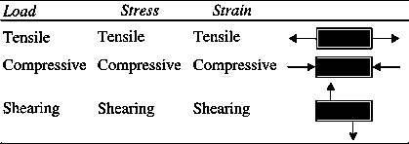

Classification of Materials
From an engineering point of view, properties concerned with metals are:
- Elasticity
- Plasticity
- Brittleness
- Malleability
- Ductility
Many of these properties are contrasting in nature so that a given metal cannot exhibit simultaneously all these properties. For example, mild steel exhibits the property of elasticity, copper possesses the property of ductility, wrought iron is malleable, lead is plastic and cast iron is brittle.

Elastic Material
II undergoes a deformation when subjected to an external loading such that the deformation disappears on the removal of the loading (rubber).

Plastic Material
It undergoes a continuous deformation during the period of loading and the deformation is permanent. It does not regain its original dimensions on the removal o\ the loading (aluminium). Rigid Material
It does not undergo any deformation when subjected to an external loading (glass and cast iron).

Malleability
Materials ability to be hammered out into thin sheets, such as lead, is called malleability.

Brittle Materials
They exhibit relatively small extensions to fracture such as glass and cast iron. There is little or no necking at fracture for brittle materials.

STRESS

Definition of Stress
Stress is an internal resistance offered by a unit area of the material, from which a member is made, to an externally applied load. Alternatively, the force per unit area or intensity of the forces distributed over a given section is called the stress on that section. The resistance of material or the internal force acting on a unit area may act in any direction.
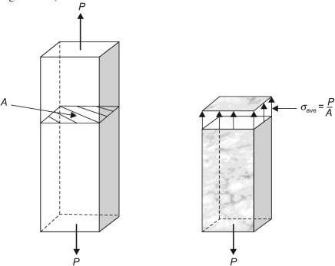
Fig. 1.1: Stress
Direct or normal stress G is calculated by using the following formula:
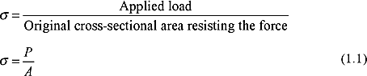

Units of Stress
The unit of stress depends upon the unit of load (or force) and unit of area. In M.K.S. units, the force is expressed in kgf and area in meter square (i.e., m²). Hence unit of stress becomes as kgf/m². If area is expressed in centimeter square (i.e., cm²), the stress is expressed as kgf/cm².
In the S.I. units, the force is expressed in newtons (written as N) and area is expressed as m². Hence unit of stress becomes as N/m². The area is also expressed in millimeter square then unit of force becomes as N/mm²
l N/m² = l N/(100cm)² = 1 N/(10⁴ cm² ) = 10⁻⁴ N/cm² or 10⁻⁶ N/mm² or 1 MPa= 1 N/mm²

Types of Stresses
The stress may be normal stress or a shear stress. Normal stress is the stress which acts in a direction perpendicular to the area. It is represented by ζ (sigma). The normal stress is further divided into tensile stress and compressive stress.

Tensile Stress:
The stress induced in a body, when subjected to two equal and opposite pulls as shown in Fig.
as a result of which there is an increase in length, is known as tensile stress. The ratio of increase in length to the original length is known as tensile strain. The tensile stress acts normal to the area and it pulls on the area.
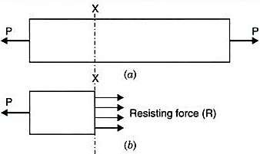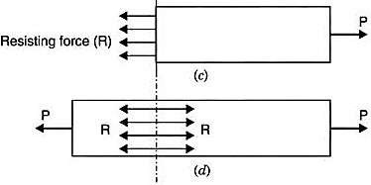
Fig. 1.2: Tensile stress
Fig. 1.2 (a) shows a bar subjected to a tensile force P at its ends. Consider a section x-x, which divides the bar into two parts. The part left to the section x-x, will be in equilibrium if P = Resisting force (R). This is shown in Fig. 1.2 (b). Similarly the part right to the section x-x, will be in equilibrium if P = Resisting force as shown in Fig. 1.2 (c). This resisting force per unit area is known as stress or intensity of stress.
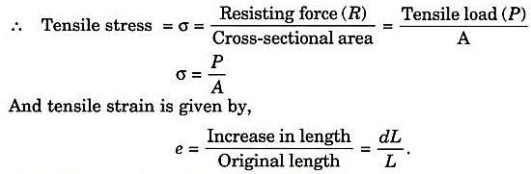

Compressive Stress:
The stress induced in a body, when subjected to two equal and opposite pushes as shown in Fig.
- as a result of which there is a decrease in length of the body, is known as compressive stress. And the ratio of decrease in length to the original length is known as compressive strain. The compressive stress acts normal to the area and it pushes on the area.Let an axial push P is acting on a body in cross-sectional area A. Due to external push P, let the original length L of the body decreases by dL.

Then compressive stress is given by,
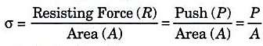
And compressive strain is given by,
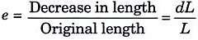
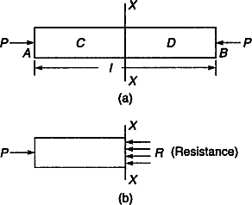
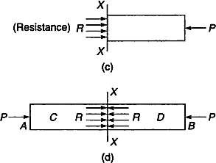

Shear Stress:
Fig. 1.3: Compressive Stress

The stress induced in a body, when subjected to two equal and opposite forces which are acting tangentially across the resisting section as shown in Fig. 1.4 as a result of which the body tends to shear off across the section, is known as shear stress. The corresponding strain is known as shear strain. The shear stress is the stress which acts tangential to the area. It is represented by τ.
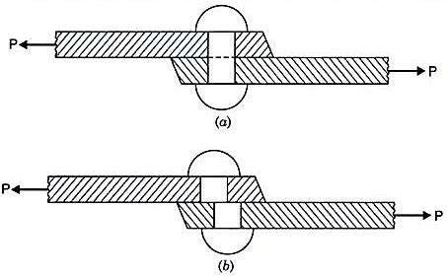

STRAIN
Fig. 1.4: Shear Stress

When a body is subjected to some external force, there is some change of dimension of the body. The ratio of change of dimension of the body to the original dimension is known as strain. Strain is dimensionless. Strain may be :
- Tensile strain

- Compressive strain,
- Volumetric strain
- Shear strain.
If there is some increase in length of a body due to external force, then the ratio of increase of length to the original length of the body is known as tensile strain. But if there is some decrease in length of the body, then the ratio of decrease of the length of the body to the original length is known as compressive strain. The ratio of change of volume of the body to the original volume is known as volumetric strain. The strain produced by shear stress is known as shear strain.

Linear Strain
It is defined as
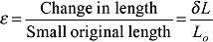
Linear strain may be either tensile or compressive. If there is some increase in the length of a body due to external force, then the strain is known as tensile strain. On the other hand, if there is some decrease in the length of the body due to external force, then the strain is known as compressive strain. Please note that both are linear strain only.
In the case of rod having uniform cross-section A. the normal stress ζ could be assumed to have a constant value P/A. Thus, it is appropriate to define ε as the ratio of the total deformation δL over the total length L of the rod.
Whereas in the case of a member of variable cross-section, however, the normal stress ζ = P/A
varies along the member, and it is necessary to define the strain at a given point as
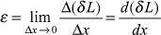

Shear Strain
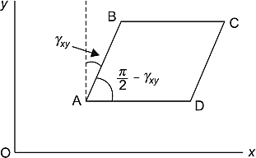
It is a measure of the angle through which a body is deformed by the applied force, denoted by γ. The shear strain is represented by the angle through which the other two faces have rotated as shown in Fig.

Volumetric Strain
Fig. 1.5: Shear strain

The ratio of change in the volume of the body to the original volume is known as volumetric strain.

LINEAR ELASTICITY AND ELASTIC LIMIT
When an external force acts on a body, the body tends to undergo some deformation. If the external force is removed and the body comes back to its original shape and size (which means the deformation disappears completely), the body is known as elastic body. This property, by virtue of which certain materials return back to their original position after the removal of the external force, is called elasticity. The body will regain its previous shape and size only when the deformation caused by the external force, is within a certain limit. Thus there is a limiting value of force up to and within which, the deformation completely disappears on the removal of the force. The value of stress corresponding to this limiting force is known as the elastic limit of the material. If the external force is so large that the stress exceeds the elastic limit, the material loses to some extent its property of elasticity. If now the force is removed, the material will not return to its original shape and size and there will be a residual deformation in the material.

HOOK’S LAW
For elastic bodies, the ratio of stress to strain is constant and is known as Young's modulus or the
modulus of elasticity and is denoted by E, i.e.,
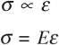
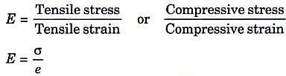

Strain has no units as it is a ratio. Thus, E has the same units as stress.
The materials that maintain this ratio are said to obey Hooke s law which states that within elastic limits, strain is proportional to the stress producing it. The elastic limit of a material is determined by plotting a tensile test diagram. Young's modulus is the stress required to cause a unit strain.

Similarly, for elastic materials, the shear strain is found to be proportional to the applied shear stress within the elastic limit. Modulus of rigidity or shear modulus denoted by G is the ratio of shear stress to shear strain, i.e.,
τ = Gγ
The ratio between the volumetric (Identical) stress and the volumetric strain is called Bulk modulus of elasticity and is denoted by K.

POISON’S RATIO
The ratio of lateral strain to the longitudinal strain is a constant for a given material, when the material is stressed within the elastic limit. This ratio is called Poisson's ratio and it is generally denoted by μ or ν or 1/m. Hence mathematically,
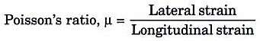

Longitudinal strain:
When a body is subjected to an axial tensile load, there is an increase in the length of the body. But at the same time there is a decrease in other dimensions of the body at right angles to the line of action of the applied load. Thus the body is having axial deformation and also deformation at right angles to the line of action of the applied load (i.e., lateral deformation).
The ratio of axial deformation to the original length of the body is known as longitudinal (or linear) strain. The longitudinal strain is also defined as the deformation of the body per unit length in the direction of the applied load.

Let L = Length of the body,
P = Tensile force acting on the body,
δL = Increase in the length of the body in the direction of P

Then, Longitudin al strain = δL L
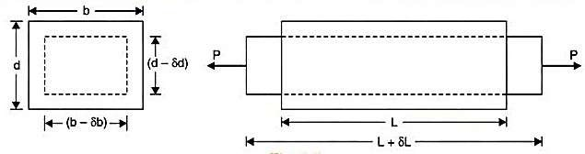
Fig. 1.6: longitudinal and lateral strain

Lateral strain:
The strain at right angles to the direction of applied load is known as lateral strain. Let a rectangular bar of length L, breadth b and depth d is subjected to an axial tensile load P as shown in Fig. 1.6. The length of the bar will increase while the breadth and depth will decrease.
Let δL = Increase in length,
δb= Decrease in breadth, and δd = Decrease in depth.
Lateral strain = δb or δd
b d
Note:
- If longitudinal strain is tensile, the lateral strains will be compressive.
- If longitudinal strain is compressive then lateral strains will be tensile.
- Hence every longitudinal strain in the direction of load is accompanied by lateral strains of opposite kind in all directions perpendicular to the load.

STRESS – STRAIN RELATIONSHIPS

For Structural Steel
Certain important properties of materials used for engineering applications can be determined by conducting laboratory tests on small specimens of the material. One such common test is tension test. Tension test involves application of gradually increasing axial tensile load on a standard specimen (the test is performed using Universal Testing Machine aptly called UTM). After performing tension or compression test and determining stress and strain at various magnitudes of load, we can obtain a diagram by plotting stress along Y-axis and strain along X-axis. The stress-strain diagram is of immense help in conveying information about mechanical properties and behaviour of the material. We shall restrict ourselves to behaviour of structural steel only. Our interest on structural steel stems out from the fact that, it is one of the most widely used metals, being used in buildings, bridges, towers, antennas and many more structures. Structural steel is also called low carbon steel or mild steel.
A typical stress strain diagram for mild steel is as shown in Figure. The initial behaviour is portrayed by straight line OA. In this region the stress is proportional to strain and thus the behaviour is linear. Beyond point A. the linear relationship no longer exists, correspondingly, the stress at A is called proportionality limit. However, the material remains elastic even beyond the limit of proportionality. The stress up to which the material behaves elastic is called elastic limit.

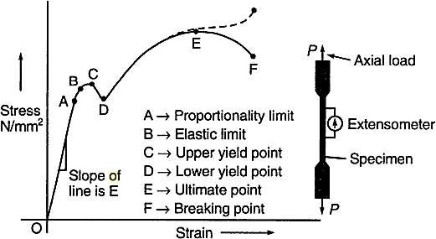

Figure: Stress-strain curve for structural steel

which is shown by point B on the curve. If the load is further increased, the material reaches a point where sudden and appreciable increase in strain occurs without appreciable increase in stress. This behaviour is shown by point C on the curve. The stress corresponding to point C (upper yield point)is called upper yield stress. An accurate testing of the specimen would reveal that the curve drops at point D (lower yield point) and the corresponding stress is called lower yield stress. In the region of upper and lower yield points, the material becomes perfectly plastic, which indicates that it can deform without an increase in applied load.
After undergoing the large strains in the region of upper and lower yield points, the steel begins to strain harden. Strain hardening is a process, where material undergoes changes in its atomic and crystalline structure. This process brings in new lease of life for the material and it picks up increased resistance to further loading (hence resistance to deformation). Thus, additional elongation requires an increase in tensile load, and stress-strain diagram mounts up with a positive slope from D to E. Point E signifies the maximum stress the material can bear and this point is called ultimate point and the corresponding stress is ultimate stress. Further, stretching of the bar is actually accompanied by drastic reduction in area and in load, and fracture finally occurs as shown by point F on the diagram.
Being a ductile material, steel specimen sustains uniform strain over the entire length up to the ultimate strength point. Figure shows that the stress decreases beyond the ultimate strength of the material and rupture does not occur until a strain considerably in excess of the strain corresponding to the ultimate stress has been reached. The strain that occurs during this phase tends to be localised over a very short length of the test specimen, leading to necking phenomenon (also called waist formation) depicted in Figure (b). This necking is typical of a metal which behave in a ductile manner. Figure (c) shows type of failures for ductile and brittle materials.

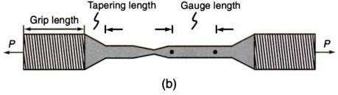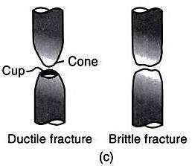
After conducting tension test on steel we can determine the following items
- Elastic modulus
- Proportional limit
- Yield stress
- Ultimate stress
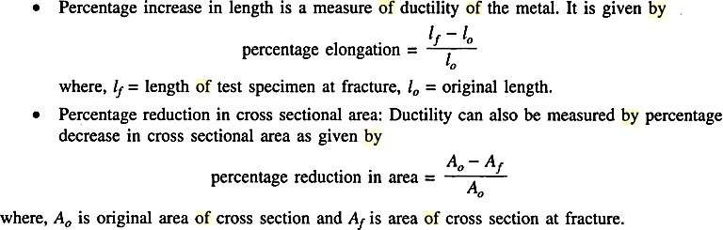

True Stress-Strain Diagram
In plotting stress-strain diagram, we make use of original area of cross section while computing all stress values and original length while calculating corresponding strains. In this context it is pertinent to define the following:

Nominal or Conventional or Engineering Stress
The ratio of load over original area of cross section of a component is nominal stress.

True Stress
The ratio of load over instantaneous area of cross section is true stress. Thus, under tensile load, instantaneous area is less than original area and under compressive load, instantaneous area is more than original area.

Nominal or Engineering Strain
Strain values are calculated at various intervals of gradually increasing load considering original gauge length of the specimen, such a strain is nominal or engineering strain. Nominal strain is change in dimension to corresponding original dimension.

True Strain
As the load keeps on increasing, the gauge length will also keep on varying (e.g., gauge length increases under tensile loading). If actual length is used in calculating the strain, the strain obtained is true strain. Crisply, change in dimension to instantaneous dimension is true strain. In most of the engineering designs, the stresses considered will be well within proportional limit and as the strain involved up to this limit is very small, the change in area is not at all appreciable. Therefore, original area of cross section is considered while defining the stress for all practical purposes.
Coming back to true stress-strain diagram, as mentioned above, the lateral contraction of the metal occurs when it is stretched under tensile load, this results in decreased cross sectional area. However, this decrease is too small to show a noticeable effect on calculated value of stress upto point D, but beyond point D, the reduction begins to alter the shape of the diagram. If the actual area is used to calculate stress, the true stress-strain curve will follow dashed line that is superposed on the diagram.

Stress-Strain Diagram for Other Materials
Every material has its own strength characteristics. Unlike steel, other materials do not show clear points of yield stress. But initial linear behaviour is shown by almost all materials. Figure presents the stress-strain behaviour of some important materials. Table presents elastic properties of certain metals.
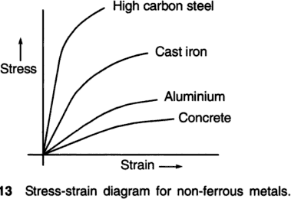

Proof Stress
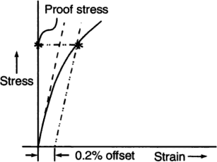
Most of the metals except steel, do not show well-defined yield point and yet undergoes large strains after the proportional limit is exceeded. An arbitrary yield stress called proof stress for these metals can be found out by offset method. On the stress-strain diagram of the metal under consideration, a line is drawn parallel to initial linear part of the curve (Figure 2.14) this line is drawn at a standard offset of strain value, such as 0.002 (0.2%). The intersection of the offset line and the stress-strain curve (point A in the figure) defines the yield point for the metal and hence yield stress. Proof stress is not an inherent property of the metal. Proof stress is also called offset yield stress.

EXTENSION / SHORTENING OF A BAR
Consider a prismatic bar of length L and cross-sectional area A subjected to axial force P. We have the relation
upon substitution of ε and ζ in that equation, we get
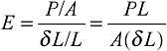
where
E = Young’s Modulus, N/mm²
L = original length , mm
δL = change in length , mm
A = original cross-sectional area, mm² and
P = axial force , N
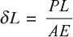
The above Eq. can also be written as,
Table 1.2 gives the values of Young's modulus of some commonly used materials.
Table 1.2: Young’s modulus of some materials
Sl. Young's modulus
no. | Material | (kN/mm²)
1 | Mild steel | 200
2 | Aluminium | 70
3 | Copper | 100
4 | Cast iron | 90
5 | Bronze | 120
6 | Wood | 10

1.8 BARS WITH CROSS SECTIONS VARYING IN STEPS
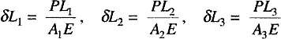
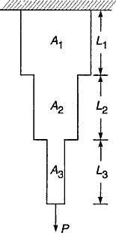
Consider a bar of varying three sections of lengths L₁ L₂ and L₃ having respective areas of cross-sections A_{1,} A₂ and A₃ subjected to an axial pull P. Let δL₁, δL₂, δL₃ be the changes in length of the respective three sections of the bar, then we have
Now the total elongation of the bar,
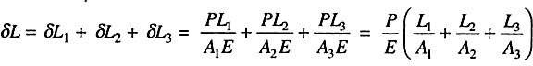

Fig. 1.7: Stepped bar

BARS WITH CONTINUOUSLY VARYING CROSS SECTIONS

Bars with varying Circular cross section
A bar uniformly tapering from a diameter D₁ at one end to a diameter D₂ at the other end is shown in Fig. 18.
Let P = Axial tensile load on the bar
L = Total length of the bar
E = Young's modulus.
Consider a small element of length dx of the bar at a distance x from the left end. Let the diameter of the bar be D at a distance x from the left end.
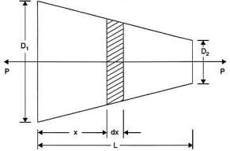
Fig. 1.8: Taper rod of circular cross section

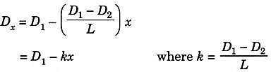
Area of cross-section of the bar at a distance x from the left end,
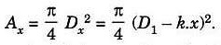
Now the stress at a distance x from the left end is given by,
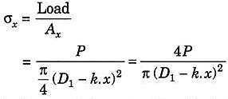
The strain e_{x} in the small element of length dx is obtained by using equation
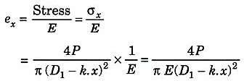
Extension of the small elemental length dx
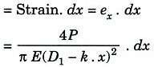
Total extension of the bar is obtained by integrating the above equation between the limits 0 and L.
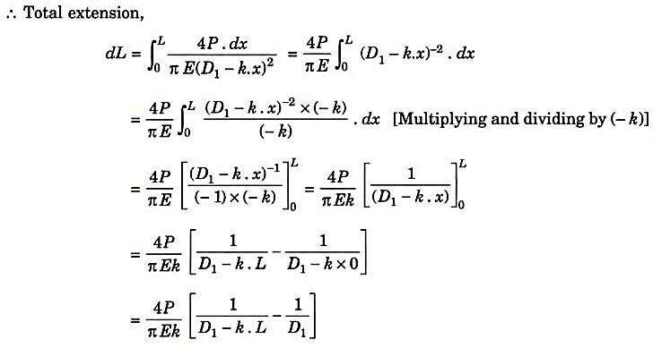
Substituting the value of k in the above equation, we get,
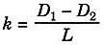

Total extension,
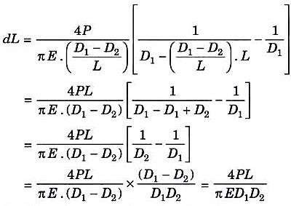
If the rod is of uniform diameter, then D₁ - D₂ = D
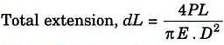

1.9.2. Bars with varying rectangular cross section
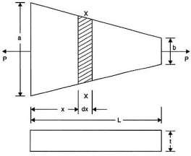
A bar of constant thickness and uniformly tapering in width from one end to the other end is shown in Fig. 1.9.
Fig. 1.9: Bars with rectangular cross section
Let P = Axial load on the bar
L = Length of bar
a = Width at bigger end b = Width at smaller end E = Young's modulus
t = Thickness of bar Consider any section X-X at a distance x from the bigger end.

Width of the bar at the section X-X
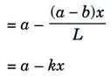
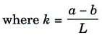

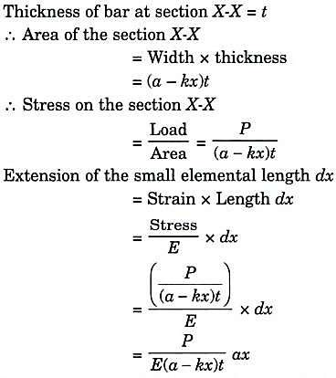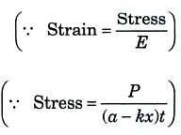
Total extension of the bar is obtained by integrating the above equation between the limits 0 and L.
Total extension,
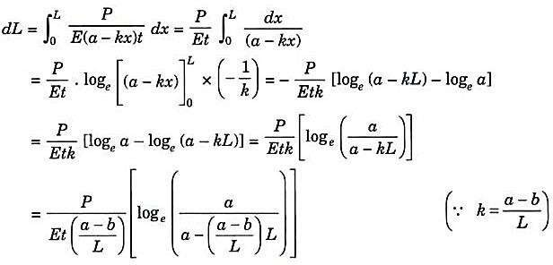
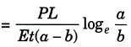

ELONGATION OF BAR DUE TO SELF WEIGHT
Consider a prismatic or circular bar of cross-sectional area A and length L hanging freely under its own weight as shown in Fig. 1.10. This circular bar experiences zero load at the free end and maximum load at the top. Weight of a body is given by the product of density and volume. Let γ be the density of the material. Consider a small section of thickness dx at a distance x from the free end.
The deformation of the element is given by
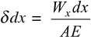

Where W_{x} = weight of the portion below the section = γ A x
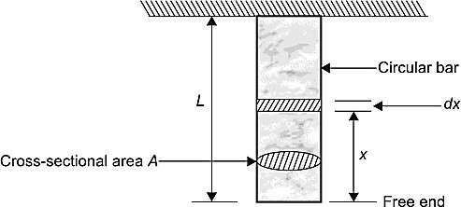
Fig.1.10: Elongation due to self weight
The extension of the entire bar can be obtained by integrating above Eq.
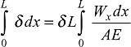
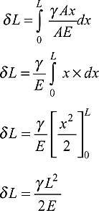

If W is the total weight of the bar, then
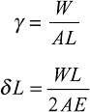
Note:
The deformation of the bar under its own weight is equal to the half of the deformation, if the body is subjected to the direct load equal to the weight of the body.

PRINCIPLE OF SUPERPOSITION.
When a number of loads are acting on a body, the resulting strain, according to principle of superposition, will be the algebraic sum of strains caused by individual loads.

While using this principle for an elastic body which is subjected to a number of direct forces (tensile or compressive) at different sections along the length of the body, first the free body diagram of individual section is drawn. Then the deformation of the each section is obtained. The total deformation of the body will be then equal to the algebraic sum of deformations of the individual sections.

WORKED EXAMPLES
- The following observations were made during a tensile test on a mild steel specimen of 40 mm diameter and 200 mm long: Elongation with 40,000 N load (within the limit of proportionality) = 0.0304 mm, Yield load = 165,000 N, Maximum load = 245,000 N, Length of the specimen at fracture = 252 mm, Determine the yield stress, the modulus of elasticity, the ultimate stress and the percentage elongation.

Solution
Given:
Diameter of the specimen = 40 mm Length of the specimen = 200 mm Load = 40,000 N
Elongation within the limit of proportionality = 0.0304 mm Yield load = 165,000 N
Maximum load = 245,000 N
Final length of the specimen = 252 mm

To find the yield stress:
Using the relation for yield stress, we have
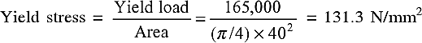

To find the modulus of elasticity:
Consider the load within the proportionality Limit. Then, stress is given by
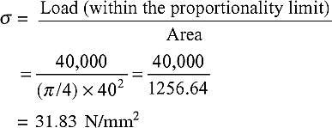
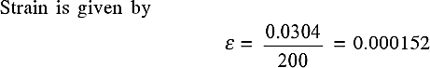

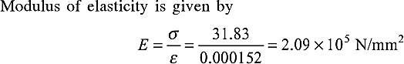

To find the ultimate stress:
Using the relation for ultimate stress, we have

To find the percentage elongation:
Using the relation, we have Percentage elongation
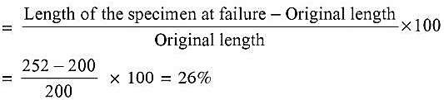
- The bar shown in Fig. is subjected to a tensile load of 60 kN. Find the diameter of the middle portion of the bar if the stress is limited to 120 N/mm². Also find the length of the middle portion if the total elongation of the bar is 0.12 mm. Take E = 2 x 10⁵ N/mm².
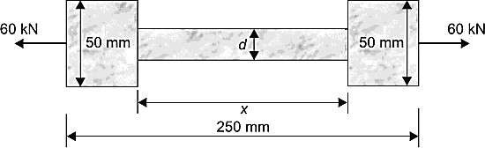

Solution
To find the diameter at the middle portion of the bar:
Stress in the middle portion of the bar is given by
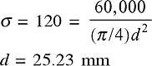
To find the length of the middle portion of the bar: Let the length of the middle portion of the bar be x Stress in the end portion is given by
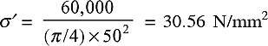

Also, total elongation = elongation of the end portion + elongation of the middle portion = 0.12 mm
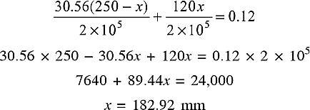

- A flat steel plate is of trapezoidal form of uniform thickness of 8 mm and tapers uniformly from a width of 60 mm to 90 mm in a length of 300 mm. Determine the elongation of the plate under the axial force of 40 kN at each end. Assume E = 205 kN/mm².

Solution:
Thickness of the plate t = 8 mm Width at one end b = 60 mm Width at other end a = 90 mm Length of the plate L = 300 mm Axial force P = 40 kN
Modulus of elasticity E = 205 kN/mm²

Using the relation, we have
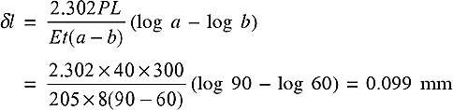
- Figure shows the bar AB of uniform cross-sectional area is acted upon by several forces. Find the deformation of the bar, assuming E = 2 x 10⁵ N/mm².
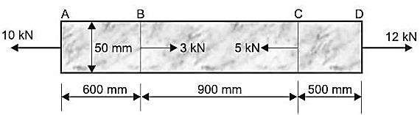
Solution: The free body diagram (F.B.D.) of individual sections is shown in Figure.

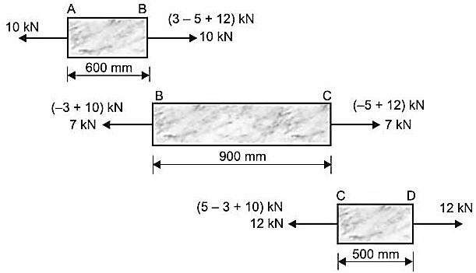
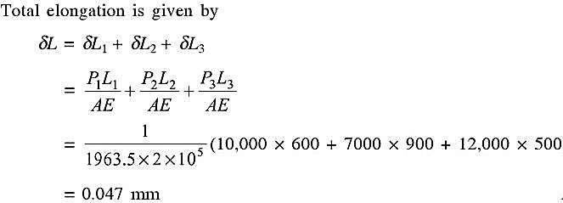
- A steel bar ABCD of varying cross-section is subjected to the axial forces as shown in Fig. Find the value of P for equilibrium. If the modulus of elasticity E = 2.1 x 10⁵ N/mm², determine the elongation of the bar.
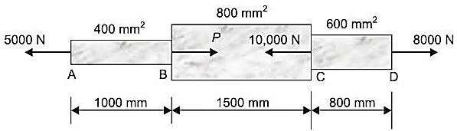

Solution:
From the equilibrium condition:

To find the elongation of the bar:

Σ F_{x}=0
+8000 -10,000 + P - 5000 = 0
P = 15,000 - 8000 = 7000 N

Consider the free body diagram (F.B.D.) of the bar,

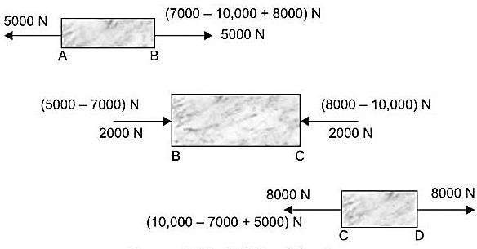
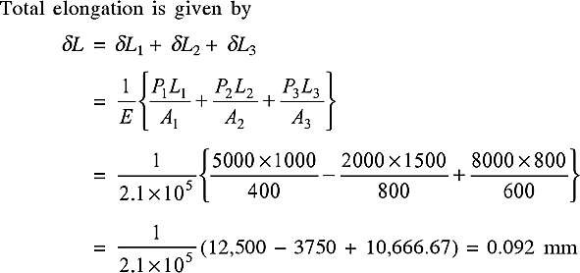

- A vertical prismatic bar is fastened at its upper end and supported at the lower end by an unyielding floor as shown in Fig. Determine the reaction R exerted by the floor of the bar if external loads P₁ = 1500 N and P₂ ⁼ 3000 N are applied at the intermediate points shown.

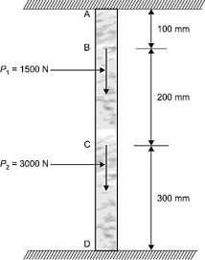
Solution
Let A be the cross-sectional area of the bar, and E be the modulus of elasticity.
Elongation of AD = elongation of AB + elongation of BC
+ elongation of the bar CD
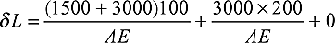
Since there is a rigid support at D, there is a reaction R at D which causes contraction of AD, i.e.
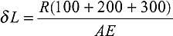
As there is no change in the length of the bar AD, we have

VOLUMETRIC STRAIN
The ratio of change in volume to the original volume of a body (when the body is subjected to a single force or a system of forces) is called volumetric strain. It is denoted by ε_{v}.
Mathematically, volumetric strain is given by

Where
ε = δV
v V

δV = Change in volume, and V = Original volume.

EXPRESSION FOR VOLUMETRIC STRAIN
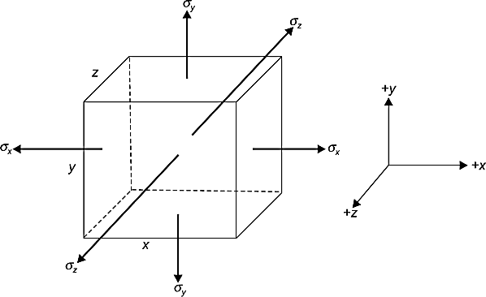
Referring to Fig.2.1, the quantity ε_{v} represents the change in the volume per unit volume. It is referred to as the dilation of the material. Consider a small rectangular element of dimensions x, y and z subjected to three mutually perpendicular stresses.
Fig. 2.1 Rectangular element subjected to three mutually perpendicular stresses.
Original volume of the element is given by
V = xyz
Therefore, the total change in the volume

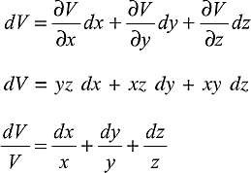

or
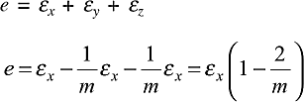
Referring to Fig.2.2, consider a bar/rod of length L and diameter d, then the volume of the bar is given by
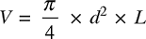

Therefore,

Fig.2.2. Volumetric strain in circular rod
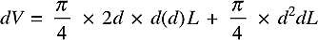
Since V is the function of both d and L, dividing previous Eq. throughout by V, we get
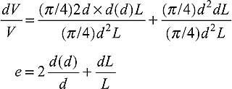
Since,
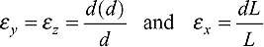
We have,
Thus, the volumetric strain is the sum of the three mutually perpendicular linear strains. Since ε_{v} represents a change in volume, it must be independent of the orientation of the element considered. It follows that the quantities,

ε_{x} + ε_{y} + ε_{z} and ζ_{x} ζ_{y} and ζ_{y} are also independent of the orientation of the element. Since,
ε_{v} = ε_{x} + ε_{y} + ε_{z}

ELASTIC CONSTANTS
Elastic constants arc those factors which determine the deformations produced by a given stress system acting on a material. These factors (i.e. elastic constants) arc constant within the limits for which Hooke's laws are obeyed. Various elastic constants are:
- Modulus of elasticity (E)
- Poisson's ratio (μ or ν or 1/m)
- Modulus of rigidity (G or N )
- Bulk modulus (K)

Young’s Modulus
When an axial stress ζ (say, tensile) is applied along the longitudinal axis of a bar, the length of the bar will be increased. This change in the length (usually called deformation) per unit length of the bar, is termed as longitudinal strain (ε) or primary strain. This ratio of stress to strain, within elastic limits, is called the modulus of elasticity (E):
Thus, modulus of elasticity (E) =ζ/ε
The modulus of elasticity (also called Young's modulus of elasticity) is the constant of proportionality which is defined as the intensity of stress that causes unit strain.
Table 2.1 gives the values of modulus of elasticity (E) for some common materials.

S. N. | Material | Modulus of elasticity E (kN/mm2 or GPa)
1 | Aluminium (Pure) | 70
2 | Aluminium alloys | 70 - 79
3 | Brass | 96 - 110
4 | Bronze | 96-120
5 | Cast iron | 83 - 170
6 | Copper (Pure) | 110 - 120
7 | Steel | 190 - 210
8 | Wrought iron | 190

Shear Modulus or Modulus of Rigidity
The shear modules or modulus of rigidity (also called the modulus of transverse elasticity) expresses the relation between shear stress and shear strain. It has been found experimentally that, within elastic limit, shear stress (η) is proportional to the shear strain (γ)
Thus G = τ
γ
Where G = modulus of rigidity
(Also sometimes denoted by symbol N or C)

Table 2.2 gives the values of modulus of rigidity for some common engineering materials.
Table 2.2. Values of modulus of rigidity

S.N. | Material | Modulus of Rigidity (KN\mm² or GPa)
1 | Aluminium (Pure) | 26
2 | Aluminium alloys | 26-30
3 | Brass | 36-41
4 | Bronze | 36-44
5 | Cast iron | 32 - 69
6 | Copper (Pure) | 40-47
7 | Steel | 75-80
8 | Wrought iron | 75

Bulk modulus
When a body is subjected to three mutually perpendicular like stresses of equal intensity (ζ), the ratio of direct stress (ζ) to the corresponding volumetric strain (ε_{v} ) is defined as the bulk modulus K for the material of the body.

Thus , bulk modulus K = Direct stress
= σ

Volumetric strain ε v

The bulk modulus of elasticity K is defined only when three mutually perpendicular normal stresses are equal, i.e.
ζ_{x} = ζ_{y} = ζ_{z} = ζ

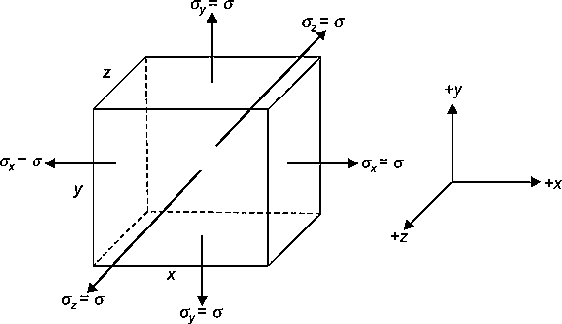

Fig. 2.3: Bulk Modulus

Relation among Elastic Constants
- Relation between E, G and υ
Let us establish a relation among the elastic constants E, G and υ. Consider a cube of material of side ‘a' subjected to the action of the shear and complementary shear stresses as shown in the Fig.
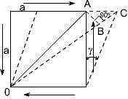
2.4 and producing the strained shape as shown in the figure below. Assuming that the strains are small and the angle A C B may be taken as 45⁰.
Fig. 2.4
Therefore strain on the diagonal OA = Change in length / original length
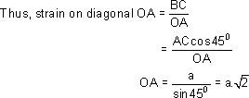
Since angle between OA and OB is very small hence OA ≅ OB therefore BC, is the change in the length of the diagonal OA

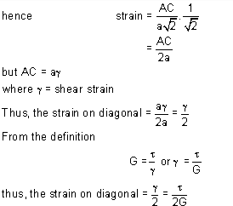

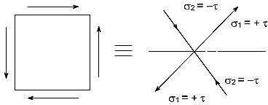
Now this shear stress system is equivalent or can be replaced by a system of direct stresses at 45⁰ as shown in Fig. 2.5. One set will be compressive, the other tensile, and both will be equal in value to the applied shear strain.
Fig. 2.5

Thus, for the direct state of stress system which applies along the diagonals:
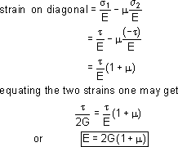

- Relation between E, K and υ:
Consider a cube subjected to three equal stresses σ as shown in the Fig.2.6
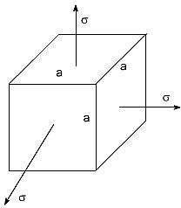
Fig.2.6
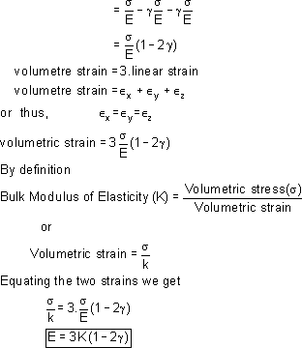
The total strain in one direction or along one edge due to the application of hydrostatic stress or volumetric stress σ is given as

- Relation between E, G and K
The relationship between E, G and K can be easily determined by eliminating υ from the already derived relations.
i.e.,
E = 2 G (1 + υ) and E = 3 K (1 − υ)
Thus, the following relationship may be obtained

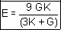

- Relation between E, K and γ
From the already derived relations, E can be eliminated
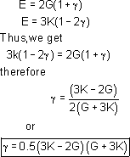

TEMPERATURE STRESSES
Thermal stresses are the stresses induced in a body due to change in temperature. Thermal stresses are set up in a body, when the temperature of the body is raised or lowered and the body is not allowed to expand or contract freely. But if the body is allowed to expand or contract freely, no stresses will be set up in the body.

Consider a body which is heated to a certain temperature. Let
L = Original length of the body,
T = Rise in temperature,
E = Young's Modulus,
α = Co-efficient of linear expansion,
dL = Extension of rod due to rise of temperature.

If the rod is free to expand, then extension of the rod is given by
dL = α.T.L
This is shown in Fig. 2.7 (a) in which AB represents the original length and BB' represents the increase in length due to temperature rise. Now suppose that an external compressive load, P is applied at B' so that the rod is decreased in its length from (L + α.T.L) to L as shown in Figs. (b) and (c).

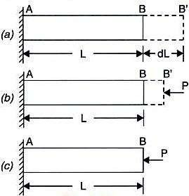
Fig. 2.7: Thermal stresses

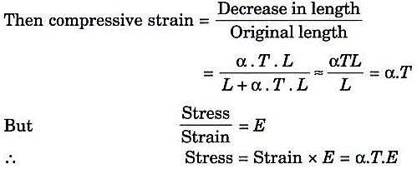
And load or thrust on the rod = Stress x Area = α.T.E x A
If the ends of the body are fixed to rigid supports, so that its expansion is prevented, then compressive stress and strain will be set up in the rod. These stresses and strains are known as thermal stresses and thermal strain.
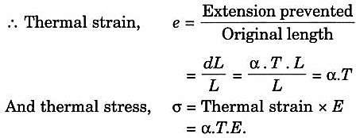
Thermal stress is also known as temperature stress. And thermal strain is also known as temperature strain.

Stress and Strain when the Supports Yield:
If the supports yield by an amount equal to δ, then the actual expansion
= Expansion due to rise in temperature - δ = α.T.L - δ
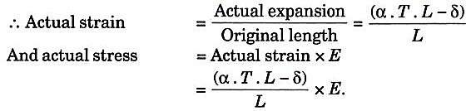

THERMAL STRESSES IN COMPOSITE BARS
Fig. 2.8 (a) shows a composite bar consisting of two members, a bar of brass and another of steel. Let the composite bar be heated through some temperature. If the members are free to expand then no stresses will be induced in the members. But the two members are rigidly fixed and hence the composite bar as a whole will expand by the same amount. As the co-efficient of linear expansion of brass is more than that of the steel, the brass will expand more than the steel. Hence the free expansion of brass will be more than that of the steel. But both the members are not free to expand, and hence the expansion of the composite bar, as a whole, will be less than that of the brass, but more than that of the steel. Hence the stress induced in the brass will be compressive whereas the stress in steel will be tensile as shown in Fig. 2.8 (c). Hence the load or force on the brass will be compressive whereas on the steel the load will be tensile.
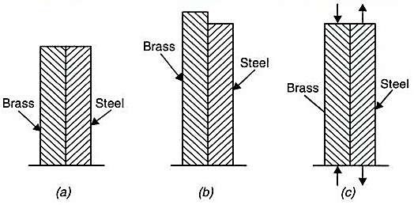
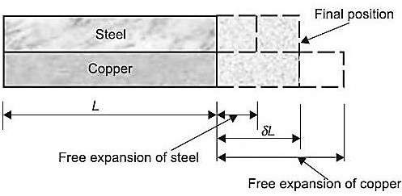
Let
A_{b} = Area of cross-section of brass bar
ζ_{b} = Stress in brass
ε_{b} = Strain in brass
α_{b} = Co-efficient of linear expansion for brass
E_{b} = Young’s modulus for copper
A_{s}, σ_{s}, ε_{s}, α_{s} = Corresponding values of area, stress, strain and co-efficient of linear expansion for steel, and
E_{s} = Young's modulus for steel.
δ = Actual expansion of the composite bar

Now load on the brass = Stress in brass x Area of brass= σ_{b} x A_{b}
And load on the steel = Stress in brass x Area of brass= σ_{s} x A_{s}
For the equilibrium of the system, compression in copper should be equal to tension in the steel or
Load on the brass = Load on the steel

Also we know that,
σ_{b} x A_{b} = σ_{s} x A_{s}

actual expansion of steel = Actual expansion of brass (i)

But actual expansion of steel = Free expansion of steel + Expansion due to tensile stress in steel
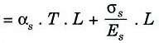
And actual expansion of copper = Free expansion of copper - Contraction due to compressive
stress induced in brass
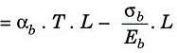
Substituting these values in equation (i), we get
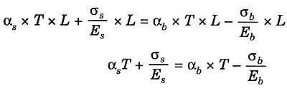
Where T = Rise of temperature.

2.6 WORKED EXAMPLES
- A metallic bar 300 mm x 100 mm x 40 mm is subjected to a force of 5 kN (tensile), 6 kN (tensile) and 4 kN (tensile) along x, y and z directions respectively. Determine the change in the volume of the block. Take E = 2 x 10⁵ N/mm² and Poisson's ratio = 0.25.
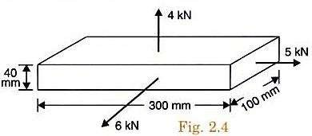
Solution:
Given: Dimensions of bar
= 300 mm x 100 mm x 40 mm
x = 300 mm, y = 100 mm and z = 40 mm V= xyz = 300 x 100x40 = 1200000 mm³
Load in the direction of x=5KN; Load in the direction of y =6KN; Load in the direction of z = 4KN
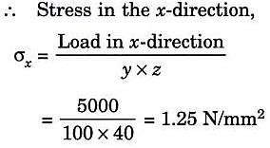
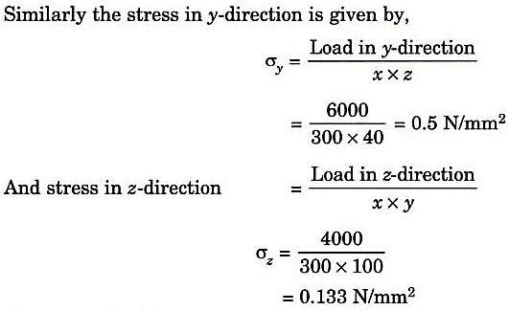

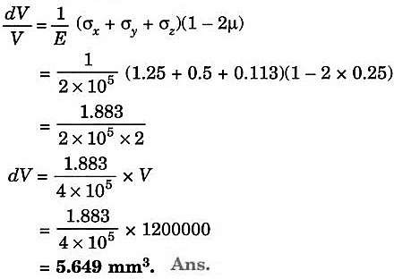

- A bar of 30 mm diameter is subjected to a pull of 60 kN. The measured extension on gauge length of 200 mm is 0.1 mm and change in diameter is 0.004 mm. Calculate: (i) Young's modulus, (ii) Poisson's ratio and (iii) Bulk modulus.
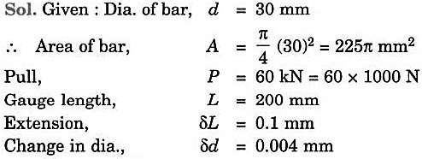
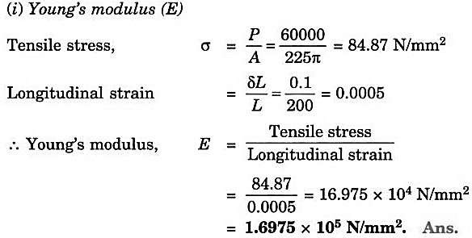
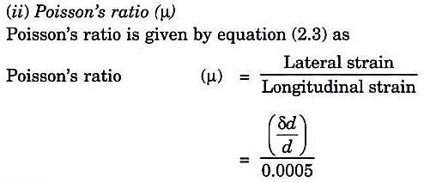

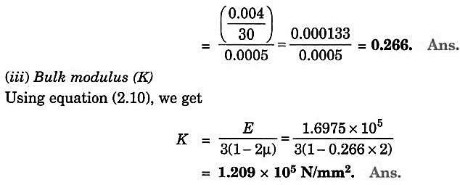

- A rod is 2 m long at a temperature of 10°C. Find the expansion of the rod, when the temperature is raised to 80°C. If this expansion is prevented, find the stress induced in the material of the rod. Take E=1.0x 10⁵ MN/m² and α = 0.000012 per degree centigrade.

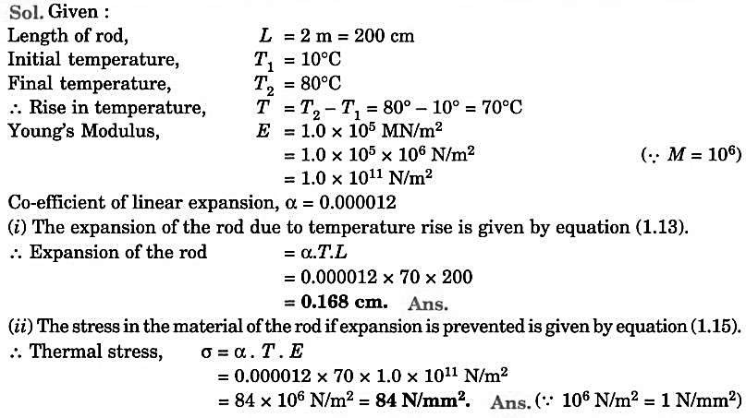
- A steel rod of 20 mm diameter passes centrally through a copper tube of 50 mm external diameter and 40 mm internal diameter. The tube is closed at each end by rigid plates of negligible thickness. The nuts are tightened lightly home on the projecting parts of the rod. If the temperature of the assembly is raised by 50°C, calculate the stresses developed in copper and steel. Take E for steel and copper as 200 GN/m² and 100 GN/m² and α for steel and copper as 12 x 10⁻⁶ per °C and 18 x 10⁻⁶ per °C.
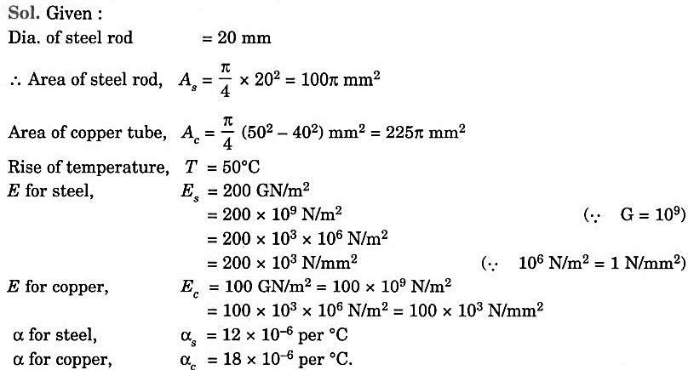
As α for copper is more than that of steel, hence the free expansion of copper will be more than that of steel when there is a rise in temperature. But the ends of the rod and the tube is fixed to the rigid plates and the nuts are tightened on the projected parts of the rod. Hence the two members are not free to expand. Hence the tube and the rod will expand by the same amount. The free expansion of the copper tube will be more than the common expansion, whereas the free expansion of the steel rod will be less than the common expansion. Hence the copper tube will be subjected to compressive stress and the steel rod will be subjected to tensile stress.

Let σ_{s} = Tensile stress in steel
σ_{c} = Compressive stress in copper.
For the equilibrium of the system,
Tensile load on steel = Compressive load on copper
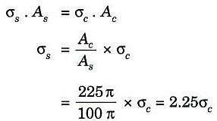 …(i)
We know that the copper tube and steel rod will actually expand by the same amount. Actual expansion of steel = Actual expansion of copper … (ii)
But actual expansion of steel
= Free expansion of steel + Expansion due to tensile stress in steel
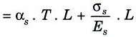
and actual expansion of copper
= Free expansion of copper - Contraction due to compressive stress in copper
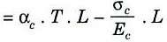
Substituting these values in equation (ii), we get

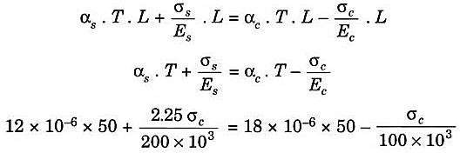

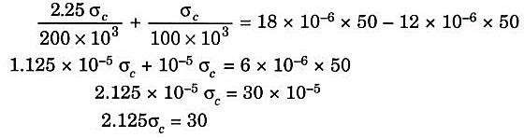
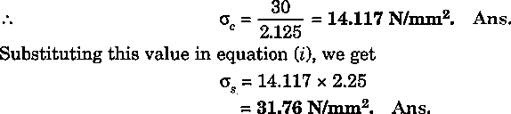

MODULE -2

TORSION OF CIRCULAR SHAFTS

INTRODUCTION
In this chapter structural members and machine parts that are in torsion will be considered. More specifically, the stresses and strains in members of circular cross section subjected to twisting couples, or torques, T and T' (Fig. 8.1) are analyzed. These couples have a common magnitude T, and opposite senses. They are vector quantities and can be represented either by curved arrows as in Fig. 3.1a, or by couple vectors as in Fig.8.1.
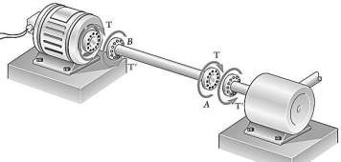
Members in torsion are encountered in many engineering applications. The most common application is provided by transmission shafts, which are used to transmit power from one point to another. For example, the shaft shown in Fig. 8.1 is used to transmit power from the engine to the rear wheels of an automobile. These shafts can be solid, as shown in Fig. 8.1, or hollow.
Fig. 8.1: Torsion in shafts

PURE TORSION
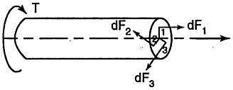
A member is said to be in pure torsion when its cross sections are subjected to only torsional moments and not accompanied by axial forces or bending moment. Now consider the section of a shaft under pure torsion as shown in Fig. 8.2.
Fig. 8.2 Pure torsion
The internal forces develop so as to counteract this torsional moment. Hence, at any element, the force dF developed is in the direction normal to radial direction. This force is obviously shearing force and thus the elements are in pure shear. If dA is the area of the element at distance r from the axis of shaft, then,
dF = τ dA
where τ is shearing stress,
and dT = dF x r

ASSUMPTIONS IN THE THEORY OF PURE TORSION
In the theory of pure torsion, expressions will be derived for determining shear stress and the effect of torsional moment on cross-section i.e. in finding angle of twist. In developing this theory the following assumptions are made.
- The material is homogeneous and isotropic.
- The stresses are within the elastic limit, i.e. shear stress is proportional to shear strain.
- Cross-sections which are plane before applying twisting moment remain plane even after the application of twisting moment i.e. no warping takes place.
- Radial lines remain radial even after applying torsional moment.
- The twist along the shaft is uniform.

DERIVATION OF TORSIONAL EQUATIONS
Consider a shaft of length L, radius R fixed at one end and subjected to a torque Tat the other end as shown in Fig. 8.3.
Let O be the centre of circular section and B a point on surface. AB be the line on the shaft parallel to the axis of shaft. Due to torque T applied, let B move to B’. If γ is shear strain (angle BOB') and θ is the angle of twist in length L, then
Rθ = BB' = Lγ

If τ_{s} is the shear stress and G is modulus of rigidity then,
γ = τ
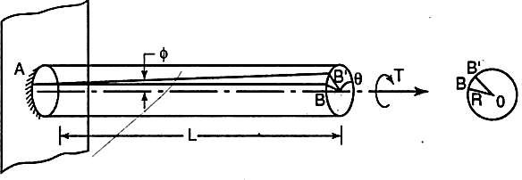
G
Fig. 8.3: Torsion in shaft
Rθ = L τ s
G
τ s = Gθ R L
Similarly if the point B considered is at any distance r from centre instead of on the surface, it can be shown that
τ = Gθ … (i)
r L
τ s =τ
R r
Thus shear stress increases linearly from zero at axis to the maximum value τ_{s} at surface. Now consider the torsional resistance developed by an elemental area 'δa' at distance r from centre.
If τ is the shear stress developed in the element the resisting force is
dF = τda

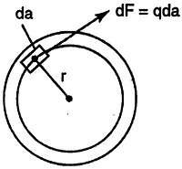

Resisting torsional moment,
Fig. 8.4

dT= dF x r
= τrda

WKT,

Therefore,

Total resisting torsional moment,

τ = τ r

s R

2
r
dT = τ s da R

But ∑r ² da
we get,

i.e., WKT,
r 2
T = ∑τ s R da
T = τ s r² da R
∑
is nothing but polar moment of inertia of the section. Representing it by notation J

T = τ s J
R
T = τ s
J R
τ s =τ
R r

There,
From (i) and (ii), we have,
T = τ
J r
(ii)

Where,
T = τ
J r
= Gθ
L
(iii)

T - torsional moment , N-mm
J - polar moment of inertia, mm⁴
τ - shear stress in the element, N/mm²
r- distance of element from centre of shaft, mm
G - modulus of rigidity, N/mm²
θ- angle of twist, rad
L- length of shaft, mm

POLAR MODULUS
From the torsion equation,

But,

T = τ
J r

τ s = τ
R r

Where τ_{s} is maximum shear stress (occurring at surface) and R is extreme fibre distance from centre. Therefore,
T = τ s
J R
or
T = J τ = Z τ

R s p s
where Z_{p} is called as 'Polar Modulus of Section’. It may be observed that Z_{p} is the property of the section and may be defined as the ratio of polar moment of inertia to extreme radial distance of the fibre from the centre.
- For solid circular section of diameter d

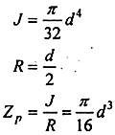
J R
- For hollow circular shaft with external diameter d1 and internal diameter d2
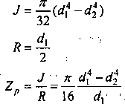

TORSIONAL RIGIDITY / STIFFNESS OF SHAFTS
From the torsion equation,
Angle of twist, θ = TL
GJ
T - Torsional moment , N-mm
J - Polar moment of inertia, mm⁴
G - Modulus of rigidity, N/mm² (sometimes denoted by C)
θ - angle of twist, rad
For a given specimen, the shaft properties like length L, polar modulus J and material properties like rigidity modulus G are constants and hence the angle of twist is directly proportional to the twisting moment or torque producing the twist. Torque producing twist in a shaft is similar to the bending moment producing bend or deflection in a beam. Similar to the flexural rigidity in beams expressed by EI, torsional rigidity is expressed as GJ which can be defined as the torque required to produce a twist of unit radian per unit length of the shaft.

POWER TRANSMITTED
Let us consider a circular shaft running at N rpm under mean torque T. Let P be the power transmitted by the shaft in kW.
The angular speed of the shaft is given by the distance covered by a particle in the circle in radians for N revolutions per second, i.e. the particle covers 2π radians for one revolution and for N revolutions the particle covers 2πN radians in one minute. Hence the angular speed ω is given by:
ω = 2πN Rad/s 60
Thus, the power transmitted = Mean torque (kN-m) x Angular speed (rad/s) i.e.,
P = Tω = 2πNT kN-m/s or kW
60
It is seen that from the above equation mean torque T in kN-m is obtained. It should be converted to N-mm so that the stress due to torque can be obtained in N/mm². Maximum shear stress due to torque can be obtained from the torque equation.

T = τ
J r
= Gθ
L

WORKED EXAMPLES
- A solid shaft has to transmit 120 kW of power at 160 rpm. If the shear stress is not to exceed 60 MPa and the twist in a length of 3 m must not exceed 1°, find the suitable diameter of the shaft. Take G = 80 GPa.
Solution
P = 120 kW, N = 160 rpm, τ = 60 N/mm², θ = 1°, G or C = 80 x 10³ N/mm², d = ? Power transmitted is given by,
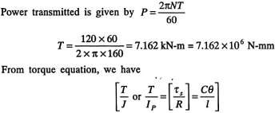

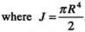
- From the maximum shear stress considerations
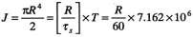

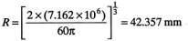

- From the maximum twist considerations
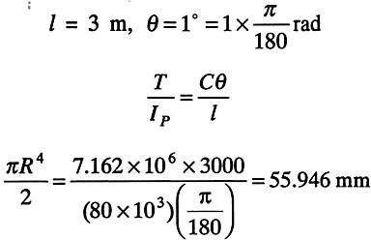
d = 2 x 55.946 = 111.89 mm
Choose the higher diameter among the two so that it can be safe.
- Find the diameter of the shaft required to transmit 60 kW at 150 rpm if the maximum torque exceeds 25% of the mean torque for a maximum permissible shear stress of 60 MN/mm². Find also the angle of twist for a length of 4 m. Take G = 80 GPa.

Solution
P = 60 kW, N = 150 rpm, τ_{s} = 60 N/mm², θ = ?, G or C = 80 x 10³ N/mm², d = ? Power transmitted is given by,
P = 2πNT
60
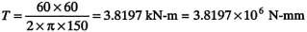
T_{max} = 1.257 = 1.25 x 3.8197 x 106 = 4.77465 x 10⁶ N mm.
From torque equation, we have

Where,

πd ⁴
J =
32

= πR³
2
T = τ
J r
= Gθ
L

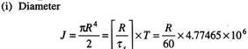
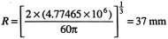
(ii) Angle of twist l = 4 m, θ = ?
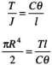

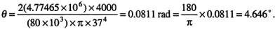

- A solid cylindrical shaft is to transmit 300 kW power at 100 r.p.m. (a) If the shear stress is not to exceed 80 N/mm², find its diameter. (b) What percent saving in weight would be obtained if this shaft is replaced by a hollow one whose internal diameter equals to 0.6 of the external diameter, the length, the material and maximum shear stress being the same?
Solution:
Given:
Power, P = 300 kW = 300 x 10³ W
Speed, N = 100rpm Max. Shear stress, σ = 80 N/mm² (a)
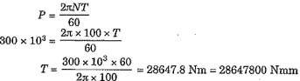
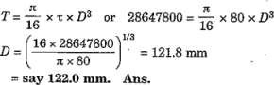
Let D = Dia. of solid shaft Power transmitted by the shaft is given by,

Percent saving in weight
Let D₀ = External dia. of hollow shaft D_{i}. = Internal dia. of hollow shaft = 0.6 x D_{o}. (given) The length, material and maximum shear stress in solid and hollow shafts are given the same. Hence torque transmitted by solid shaft is equal to the torque transmitted by hollow shaft.

But the torque transmitted by hollow shaft is given by equation,
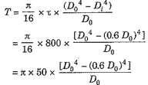
But torque transmitted by solid shaft = 28647800 N-mm. Equating the two torques, we get

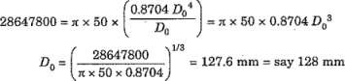

Internal dia, D_{i} = 0.6 x D₀ = 0.6 x 128 = 76.8 mm
Let, W_{s} = Weight of solid shaft,
W_{h} = Weight of hollow shaft.
Let, W_{s} = Weight density x Area of solid shaft x Length
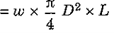
Similarly,
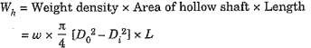
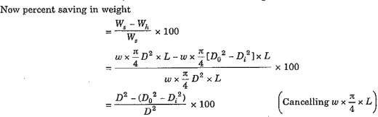
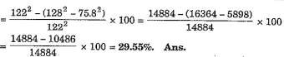

- A hollow shaft of diameter ratio 3/8 is to transmit 375 kW power at 100 r.p.m. The maximum torque being 20% greater than the mean. The shear stress is not to exceed 60 N/mm² and twist in a length of 4 m not to exceed 2°. Calculate its external and internal diameters which would satisfy both the above conditions. Assume modulus of rigidity, C = 0.85 x 10⁵ N/mm².
Solution:
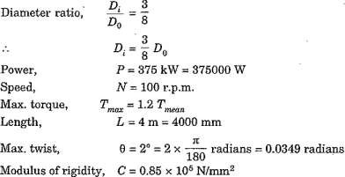

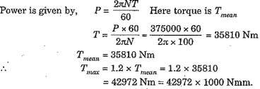

Diameters of the shaft when shear stress is not to exceed 60 MPa,
For the hollow shaft, the torque transmitted is given by
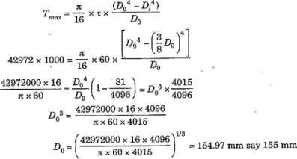

(ii) Diameters of the shaft when the twist is not to exceed 2 degrees.
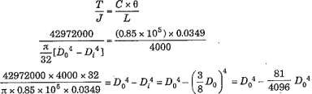
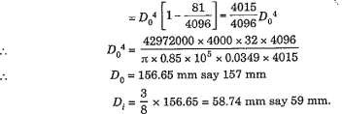

The diameters of the shaft, which would satisfy both the conditions, are the greater of the two values.
External dia., D0 = 157 mm.
Internal dia., Di = 59 mm.

Module: III

FORCES AND DEFLECTIONS IN BEAMS

Syllabus
Introduction, Types of beams, loads and reactions, shear forces and bending moments, rate of loading, sign conventions, relationship between shear force and bending moments. Shear force and bending moment diagrams for different beams subjected to concentrated loads, uniformly distributed load, (UDL) uniformly varying load (UVL) and couple for different types of beams.

INTRODUCTION
Shear and bending moment diagrams are analytical tools used in conjunction with structural analysis to help perform structural design by determining the value of shear force and bending moment at a given point of a structural element such as a beam. These diagrams can be used to easily determine the type, size, and material of a member in a structure so that a given set of loads can be supported without structural failure. Another application of shear and moment diagrams is that the deflection of a beam can be easily determined using either the moment area method or the conjugate beam method.
The algebraic sum of the vertical forces at any section of a beam to the right or left of the section is known as shear force. It is briefly written as S.F. The algebraic sum of the moments of all the forces acting to the right or left of the section is known as bending moment. It is written as
B.M. In this chapter, the shear force and bending moment diagrams for different types of beams (i.e., cantilevers, simply supported, fixed, overhanging etc.) for different types of loads (i.e., point load, uniformly distributed loads, varying loads etc.) acing on the beams, will be considered.

TYPES OF BEAMS
The following are the important types of beams:
1. Cantilever beam, 2. Simply supported beam,
3. Overhanging beam, 4. Fixed beams, and
5. Continuous beam.

Cantilever Beam.
A beam which is fixed at one of its end and the other end is free is called a cantilever beam. Figure
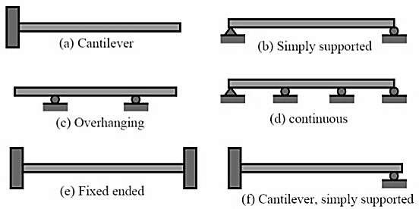
(a) shows a cantilever beam with one end rigidly fixed and the other end free. The distance between fixed and free ends is called the length of the beam.

Simply Supported Beam
Fig.5.1: Types of beams

A beam which is freely supported at both ends is called a simply supported beam. The term 'freely supported' implies that the end supports exerts only the forces upon the bar but not the moments. Therefore there is no restraint offered to the angular rotation of the ends of the bar at the supports as the bar deflects under the loads. The beam is shown in Fig. 5.1 (b).

Overhanging Beam
The beam freely supported at any two points and having one or both ends projected beyond these supports is called an overhanging beam. Fig. 5.1 (c).

Fixed Beams
A beam, whose both ends are fixed or built-in walls, is known as fixed beam. Such beam is shown in Fig. 5.1 (d). A fixed beam is also known as a built-in or encastred beam.

Continuous Beam
A beam which is provided more than two supports as shown in Fig. 5.1 (e), is known as continuous beam.

TYPES OF LOADS

Concentrated Load
This type of load acts relatively on a smaller area. For example, the force exerted by a chair or a table leg on the supporting floor or load exerted by a beam on a supporting column are both considered to be concentrated. This type of loading is shown in Fig. 5.2(a).
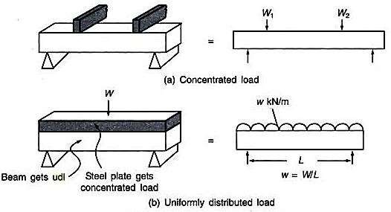
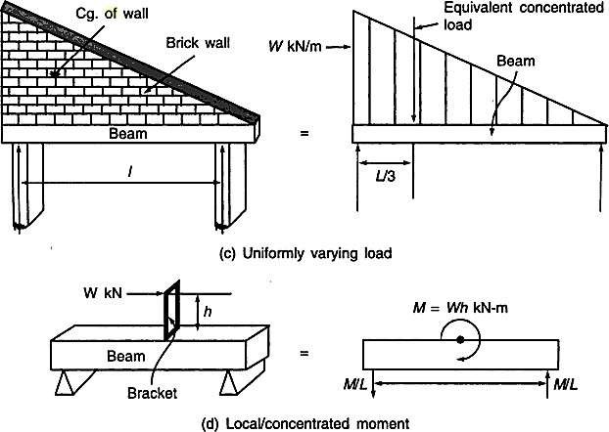
Fig. 5.2. Types of loads

Uniformly Distributed Load (UDL)
As the name itself implies, uniformly distributed load is spread over a large area. Its magnitude is designated by its intensity (N/m or kN/m). The water pressure on the bottom slab of a water tank is an example of such a loading. If a floor slab is supported by beams,

the load of the slab on the beams is certainly uniformly distributed. To be simple, the self- weight of the beam itself is uniformly distributed. For convenience, uniformly distributed load is always converted into its equivalent concentrated load acting at the centre of gravity of the loading. This type of load is shown in Fig. 5.2 (b).

Uniformly Varying Load (UVL)
This type of load will be uniformly varying from zero intensity at one end to the designated intensity at the other end. A triangular block of brickwork practically imposes such a loading on a beam. The water pressure distribution on the walls of a water tank could be another example. Here again, equivalent concentrated load (equal to area of the loading triangle) is to be used while dealing with this load. The loading, its equivalent replacement and its location is displayed in Fig. 5.2 (c).

Concentrated Moment
If for some purpose, a beam is to accommodate a load on a bracket mounted on it, what gets transmitted on the beam is a concentrated moment as shown in Fig. 5.2 (d).

REACTIONS AT SUPPORTS OF BEAMS
A beam is a structural member used to support loads applied at various points along its length. Beams are generally long, straight and prismatic (i.e. of the same cross-sectional area throughout the length of the beam).
Types of Supports:
Beams are supported on roller, hinged or fixed supports as shown in Fig.5.3.
Simple Support:

If one end of the beam rests in a fixed support, the support is known as simple support. The reaction of the simple support is always perpendicular to the surface of support. The beam is free to slide and rotate at the simple support. See Fig. 5.3(a).
Roller Support:

Here one end of the beam is supported on a roller. The only reaction of the roller support is normal to the surface on which the roller rolls without friction. See Fig. 5.3 (b) in which four possible situations are illustrated. Examples of roller supports are wheels of a motorcycle, or a handcart, or an over-head crane, or of a car, etc.
Hinged Support:
At the hinged support [see Fig.5.3 (c)] the beam does not move either along or normal to its axis. The beam, however, may rotate at the hinged support. The total support reaction is R and its

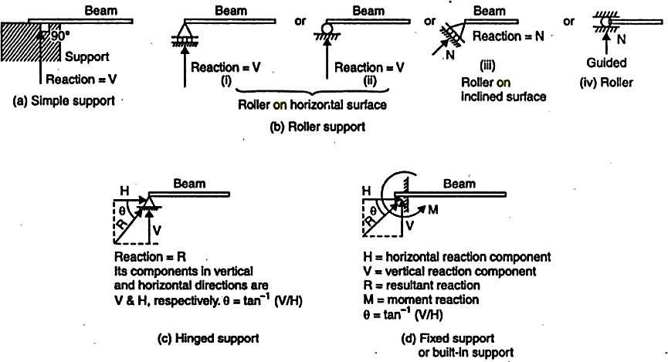
horizontal and vertical components are H and V, respectively. Since the beam is free to rotate at the hinged support, no resisting moment will exist. The hinged support behaves like the hinges provide to doors and windows.
Fig. 5.3: Types of supports and reactions

Fixed Support:
At the fixed support, the beam is not free to rotate or slide along the length of the beam or in the direction normal to the beam. Therefore, there are three reaction components, viz., vertical reaction component (V), horizontal reaction component (H) and the moment (M), as shown in Fig.5.3 (d). Fixed support is also known as built-in support.

SHEAR FORCES AND BENDING MOMENT DIAMGRAMS

Definition of Shear force and bending moment
A shear force (SF) is defined as the algebraic sum of all the vertical forces, either to the left or to the right hand side of the section.
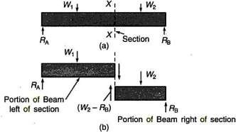
Fig. 5.4. Shear force at section

A bending moment (BM) is defined as the algebraic sum of the moments of all the forces either to the left or to the right of a section.
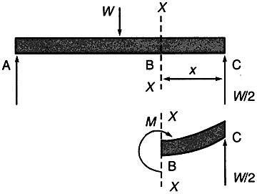

Fig. 5.5. Bending moment at section
Bending Moment at section x-x =
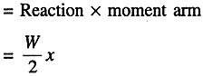

Sign convention of SF and BM
For Shear force:
We shall remember one easy sign convention, i.e., to the right side of a section, external force acting in upward direction is treated as negative (remember this convention as RUN —» Right side of a section Upward force is Negative). It is automatic that a downward force acting to the right side of a section be treated as positive. Sign convention is shown in Fig.5.6. The signs become just reversed when we consider left side of section.
(A shear force which tends to rotate the beam in clockwise direction is positive and vice versa)
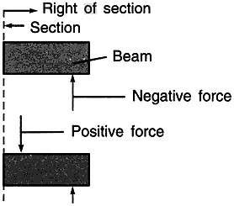
Fig. 5.6: Sign convention of SF

For Bending moment:
The internal resistive moment at the section that would make the beam to sag (means to sink down, droop) is treated to be positive. A sagged beam will bend such that it exhibits concave curvature at top and convex curvature at bottom. Positive bending moment is shown in Fig. 5.7

    - The internal resistive moment that would hog the beam is treated as negative. A hogged beam will show convex curvature at top and concave curvature at bottom. Negative bending moment is shown in Fig. 5.7(b).
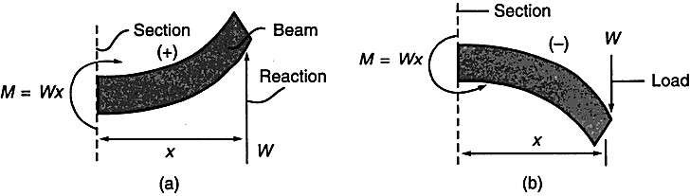

SFD and BMD definitions
Fig. 5.7: Sign convention for BM

It is clear from foregone discussions that at a section taken on a loaded beam, two internal forces can be visualized, namely, the bending moment and the shear force. It is also understood that the magnitude of bending moment and shear force varies at different cross sections over the beam. The diagram depicting variation of bending moment and shear force over the beam is called bending moment diagram [BMD] and shear force diagram [SFD]. Such graphic representation is useful in determining where the maximum shearing force and bending moment occur, and we need this information to calculate the maximum shear stress and the maximum bending stress in a beam. The moment diagram can also be used to predict the qualitative shape of the deflected axis of a beam.

General Guidelines on Construction of SFD and BMD
Before we go on to solving problems, several standard procedures (or practices) in relation with construction of shear force and bending moment diagrams need to be noted.
      - The load, shear and bending moment diagrams should be constructed one below the other, in that order, all with the same horizontal scale.
      - The dimension on the beam need not be scaled but should be relative and proportionate (a 3 m span length should not look more than 5 m length!).
      - Ordinates (i.e., BM and SF values) need not be plotted to scale but should be relative. Curvature may need to be exaggerated for clarity.
      - Principal ordinates (BM and SF values at salient points) should be labeled on both SFD and BMD.
      - A clear distinction must be made on all straight lines as to whether the line is horizontal or has a positive or negative slope.
      - The entire diagram may be shaded or hatched for clarity, if desired.

Variation of shear force and bending moment diagrams

S.N | Point Load | UDL | UVL
Shear Force | Constant | Linear | Parabolic
Bending Moment | Linear | parabolic | Cubic

WORKED EXAMPLES
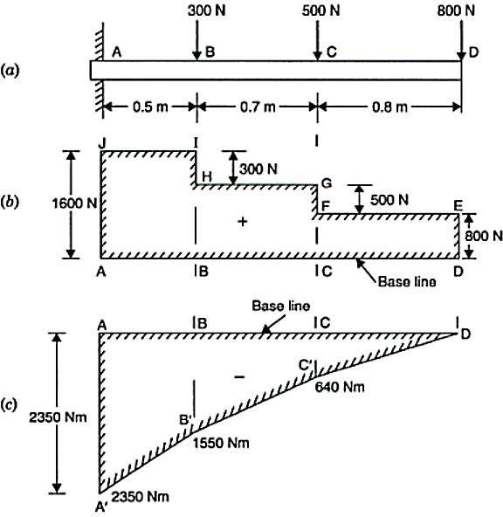
- A cantilever beam of length 2 m carries the point loads as shown in Fig. Draw the shear force and B.M. diagrams for the cantilever beam.
Shear Force Diagram
S.F. at D, F_{D} = + 800 N
S.F. at C, F_{c} = + 800 + 500 = + 1300 N
S.F. at B, F_{B} = + 800 + 500 + 300 = 1600 N
S.F. at A, F_{A} = + 1600 N.
The shear force, diagram is shown in Fig.

Bending Moment Diagram
The bending moment at D is zero
B.M. at C, M_{C} = - 800 x 0.8 = - 640 Nm.
B.M. at B, M_{B} = - 800 x 1.5 - 500 (1.5 - 0.8)
= 1200 - 350 = - 1550 Nm.
The B.M. at A, M_{A} = - 800 x 2 - 500 (2 - 0.8) - 300 (2 - 1.5)
= - 800 x 2 - 500 x 1.2 - 300 x 0.5
= - 1600 - 600 - 150 = - 2350 Nm.
Summary M_{D} = 0
M_{c} = - 640 Nm M_{B} = - 1550 Nm M_{A} = - 2350 Nm.
The bending moment diagram is shown in Fig.
- A simply supported beam of length 6 m carries point load of 3 kN and 6 kN at distances of 2 m and 4 m from the left end. Draw the shear force and bending moment diagrams for the beam.
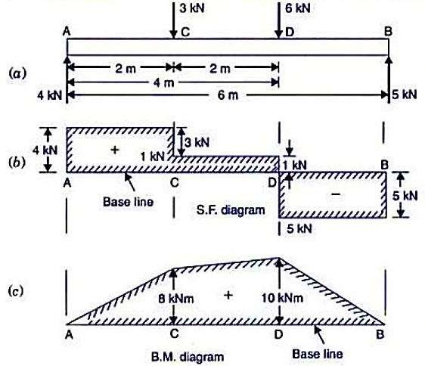
First calculate the reactions R_{A} and R_{B}. Upward load =Downward loads
R_{A}+ R_{B} = 9 kN

Taking moments of the force about A, R_{B}x6 = 3x2 + 6x4 = 30
R_{B} = 5 kN ; R_{A} = 4 kN
Shear Force Diagram
Shear force at A, F_{A} = + R_{A} = + 4 kN
Shear force between A and C is constant and equal to + 4 kN Shear force at C, F_{c} = + 4 - 3.0 = + 1 kN
Shear force between C and D is constant and equal to + 1 kN. Shear force at D, F_{D} = + l - 6 = -5kN
The shear force between D and B is constant and equal to - 5 kN. Shear force at B, F_{B} = -5 kN
The shear force diagram is drawn as shown in Fig.
Bending Moment Diagram
B.M. at A, M_{A} = 0
B.M. at C, M_{c} = R_{A} x 2 = 4x2 = + 8 kNm
B.M. at D M_{D} = R_{A} x 4 – 3 x 2 = 4 x 4 – 3 x 2 = + 10 kNm
B.M. at B, M_{B} = 0
The bending moment diagram is drawn as shown in Fig.

- Draw the S.F. and BM. diagrams for the overhanging beam carrying uniformly distributed load of 2 kN/m over the entire length and a point load of 2 kN as shown in Fig. Locate the point of contra-flexure.
First calculate the reactions R_{A} and R_{B}. Upward forces = Downward forces R_{A} + R_{B} = 2 X 6 +2 = 14 kN
Taking moments of all forces about A, we get R_{B} x 4 = 2 x 6 x 3 + 2 x 6 = 48 kNm
R_{B} = 12 kN ; R_{A} = 2 kN
Shear force diagram

Shear force  At point | Shear force towards
 | Left of the section | Right of the section
A | -- | 2x6 + 2 – 12 = 2kN
B | 2 – 2 x 4 = -6 kN | 2 x 2 +2 = 6 kN
C | 2 + 12 – 2 x 6 = 2 kN | --

Bending Moment Diagram:
M_{A} = 0
M_{B} = -(2 x 2) x 1 – 2 x 2 = -8kN-m
M_{C} = 0
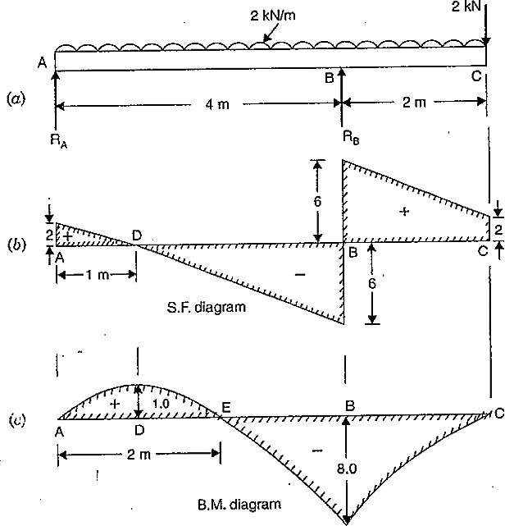
To find maximum bending moment:
WKT, bending moment is maximum where shear force is zero. Therefore, FD = 0 = R_{A} -2 x x ; x=1m
M_{D} = 2 x 1 – 2 x 1 x 0.5 = 1 kN-m
Point of Contra-flexure
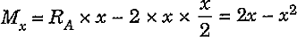
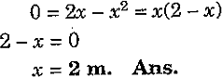
This point is at E between A and B, where B.M. is zero after changing its sign. The distance of E from A is obtained by putting M_{x} = 0 ,in the following equation

Module: IV

STRESSES IN BEAMS

Syllabus
Introduction, Theory of simple bending, assumptions in simple bending, Bending stress equation, relationship between bending stress, radius of curvature, relationship between bending moment and radius of curvature, Moment carrying capacity of a section. Shearing stresses in beams, shear stress across rectangular, circular, symmetrical I and T sections. (composite / notched beams not included).

INTRODUCTION
When some external load acts on a beam, the shear force and bending moments are set up at all sections of the beam. Due to the shear force and bending moment, the beam undergoes certain deformation. The material of the beam will offer resistance or stresses against these deformations. These stresses with certain assumptions can be calculated. The stresses introduced by bending moment are known as bending stresses. In this chapter, the theory of pure bending, expression for bending stresses, bending stress in symmetrical and unsymmetrical sections, strength of a beam and composite beams will be discussed.
E.g., Consider a piece of rubber, most conveniently of rectangular cross-section, is bent between one’s fingers it is readily apparent that one surface of the rubber is stretched, i.e. put into tension, and the opposite surface is compressed.

SIMPLE BENDING
A theory which deals with finding stresses at a section due to pure moment is called bending theory. If we now consider a beam initially unstressed and subjected to a constant B.M. along its length, it will bend to a radius R as shown in Fig. b. As a result of this bending the top fibres of the beam will be subjected to tension and the bottom to compression. Somewhere between the two surfaces, there are points at which the stress is zero. The locus of all such points is termed the neutral axis (N.A). The radius of curvature R is then measured to this axis. For symmetrical sections the N.A. is the axis of symmetry, but whatever the section the N.A. will always pass through the centre of area or centroid.

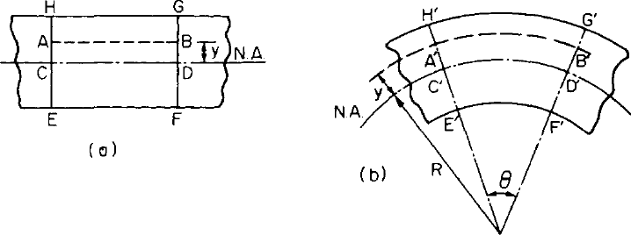

Beam subjected to pure bending (a) before, and (b) after, the moment

M has been applied.

In simple bending the plane of transverse loads and the centroidal plane coincide. The theory of simple bending was developed by Galelio, Bernoulli and St. Venant. Sometimes this theory is called Bernoulli's theory of simple bending.

ASSUMPTIONS IN SIMPLE BENDING
The following assumptions are made in the theory of simple bending:
  - The beam is initially straight and unstressed.
  - The material of the beam is perfectly homogeneous and isotropic, i.e. of the same density and elastic properties throughout.
  - The elastic limit is nowhere exceeded.
  - Young's modulus for the material is the same in tension and compression.
  - Plane cross-sections remain plane before and after bending.
  - Every cross-section of the beam is symmetrical about the plane of bending, i.e. about an axis perpendicular to the N.A.
  - There is no resultant force perpendicular to any cross-section.
  - The radius of curvature is large compared to depth of beam.

DERIVATION OF BENDING EQUATION
Consider a length of beam under the action of a bending moment M as shown in Fig. 6.2a. N-N is the original length considered of the beam. The neutral surface is a plane through X-X. In the side view NA indicates the neutral axis. O is the centre of curvature on bending (Fig. 6.2b).

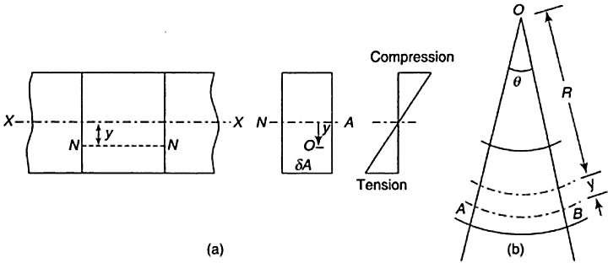

Fig. 6.2
Let R = radius of curvature of the neutral surface
θ = angle subtended by the beam length at centre O
σ = longitudinal stress
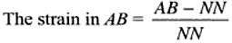
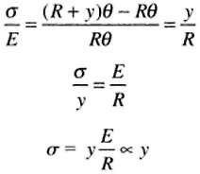
A filament of original length NN at a distance v from the neutral axis will be elongated to a length AB

..(i)
Thus stress is proportional to the distance from the neutral axis NA. This suggests that for the sake of weight reduction and economy, it is always advisable to make the cross-section of beams such that most of the material is concentrated at the greatest distance from the neutral axis. Thus there is universal adoption of the I-section for steel beams. Now let δA be an element of cross- sectional area of a transverse plane at a distance v from the neutral axis NA (Fig. 6.2).

For pure bending, Net normal force on the cross-section = 0
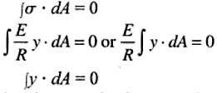

This indicates the condition that the neutral axis passes through the centroid of the section. Also, bending moment = moment of the normal forces about neutral axis
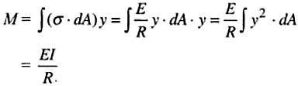
Or M = E (ii)
I R
Where I = ∫ y ²dA and is known as the moment of inertia or second moment of area of the section. From (i) and (ii),

Where,
M = E = σ
I R y

M = Bending Moment at a section (N-mm).
I = Moment of Inertia of the cross section of the beam about Neutral axis (mm⁴).
σ = Bending stress in a fibre located at distance y from neutral axis (N/mm²). This stress could be compressive stress or tensile stress depending on the location of the fibre.
y = Distance of the fibre under consideration from neutral axis (mm).
E = Young's Modulus of the material of the beam (N/mm²).
R = Radius of curvature of the bent beam (mm).

SECTION MODULUS
The maximum tensile and compressive stresses in the beam occur at points located farthest from the neutral axis. Let us denote y₁ and y₂ as the distances from the neutral axis to the extreme fibres at the top and the bottom of the beam. Then the maximum bending normal stresses are

σ bc
= My₁
I
= M I y₁
= M ,
Z_{t}
σ bc

is bending compressive stress in the topmost layer.

Similarly,

σ bt
= My₂
I
= M M
I y₂ Z_{b}
=
,
σbt

is bending compressive stress in the topmost layer.

Here, Z_{t} and Z_{b} are called section moduli of the cross sectional area, and they have dimensions of length to the third power (ex. mm³). If the cross section is symmetrical (like rectangular or square sections), then Z_{t} = Z_{b} = Z, and Z is called as section modulus. Section modulus is defined

as the ratio of rectangular moment of inertia of the section to the distance of the remote layer from the neutral axis. Thus, general expression for bending stress reduces to
σ = M
Z
It is seen from the above expression that for a given bending moment, it is in the best interests of the designer of the beam to procure high value for section modulus so as to minimise the bending stress. More the section modulus designer provides for the beam, less will be the bending stress generated for a given value of bending moment.

MOMENT CARRYING CAPACITY OF A SECTION
From bending equation we have
σ = My
I
It shows bending stress is maximum on the extreme fibre where y is maximum. In any design this extreme fibre stress should not exceed maximum permissible stress. If σ_{per} is the permissible stress, then in a design
σ max ≤ σ per
M y ≤ σ
I per
Or if M is taken as maximum moment carrying capacity of the section,
M

I ymax
= σ per

Or M = I ymax
σ per

The moment of inertia I and extreme fibre distance y_{max} are the properties of cross-section. Hence, I/y_{max} is the property of cross-sectional area and is termed as section modulus and is denoted by Z. Thus the moment carrying capacity of a section is given by
M = σ per Z
If permissible stresses in tension and compression are different, moment carrying capacity in tension and compression are found separately by considering respective extreme fibres and the smallest one is taken as moment carrying capacity of the section.

Expressions for section modulus of various standard cross-sections are derived below.
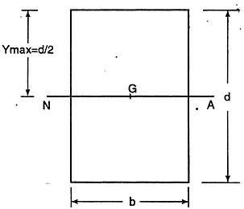
Rectangular section of width b and depth d:
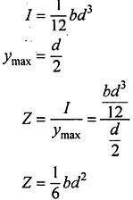

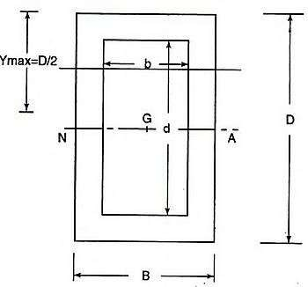
Hollow rectangular section with symmetrically placed opening:
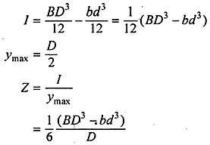
Consider the section of size B ^{x} D with symmetrical opening bx d as shown in Fig..
Circular section of diameter d
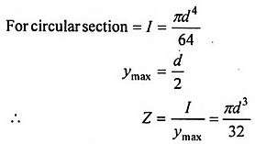
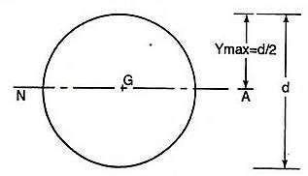
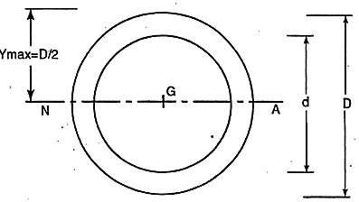
Hollow circular section of uniform thickness:

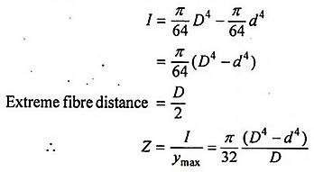

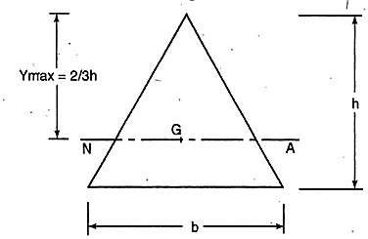
Triangular Section
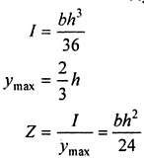

SHEARING STRESSES IN BEAMS

we know that beams are usually subjected to varying bending moment and shearing forces. The relation between bending moment M and shearing force F is dM/dx=F. Bending stress act longitudinally and its intensity is directly proportional to its distance from neutral axis. Now we will find the stresses induced by shearing force.
Consider an elemental length of beam between the sections A-A and B- B separated by a distance dx as shown in Fig. 6.3a. Let the moments acting at A- A and B-B be M and M+dM.
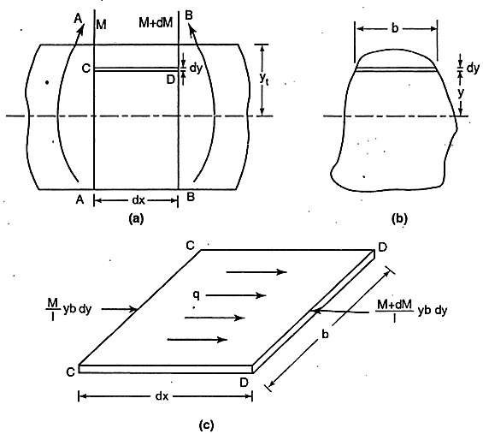
Fig. 6.3

Let CD be a fibre at a distance y-from neutral axis. Then bending stress at left side of the element
= M y I

The force on the element on left side

= M ybdy I

Similarly due to bending, force on the right side of the element

= M + dM
I
ybdy

Unbalanced force towards right in element

= M + dM
I
ybdy − M
I
ybdy = dM
I
ybdy

There are a number of such elements above section CD. Hence unbalance horizontal force above
section CD
y' dM
∫
= ybdy
_{y} I

This horizontal force is resisted by shearing stresses acting horizontally on plane at CD. Let intensity of shearing stress be q. Then equating shearing force to unbalanced horizontal force we get '
^{y} dM

=τbdx =
∫
I
y
ybdy

dM 1 y'
Or τ = ⋅ ∫ ya dx bI y

Where a = b dy is area of element.
y'
∫
The term ya can be looked as
y

y'
∑ ay = ay
y

Where ay is the moment of area above the section under consideration about neutral axis.
From equation, dM/dx=F
τ = F ay
bI
From the above expression it may be noted that shearing stress on extreme fibre is zero.

6.8 SHEAR STRESSES ACROSS RECTANGULAR SECTIONS
Consider a rectangular section of width b and depth d subjected to shearing force F. Let A-A be the section at distance y from neutral axis as shown in Fig. 6.4.
We know that shear stress at this section.
τ = F ay
bI

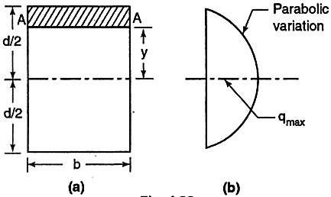

where ay
Fig. 6.4
is the moment of area above this section (shown shaded) about the neutral axis.

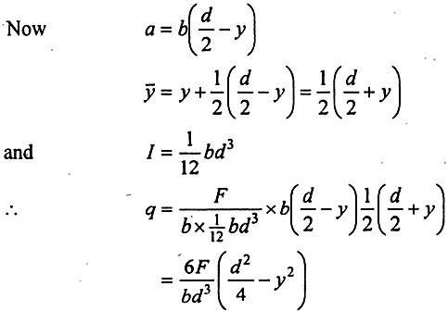

i.e., shear stress varies parabolically.
When y=d/2, τ = 0
y=d/2, τ = 0
y = 0, τ is maximum and its value is

τ max

= 6F d ²
bd ³ 4

Where
= 1.5 F
bd
= 1.5τ

avg

τ avg
= ShearingForce = F
Area bd

Thus, maximum shear stress is 1.5 times the average shear stress in rectangular section and occurs at the neutral axis. Shear stress variation is parabolic. Shear stress variation diagram across the section is shown in Fig.6.4b.

WORKED EXAMPLES
- A simply supported beam of span 5 m has a cross-section 150 mm * 250 mm. If the permissible stress is 10 N/mm², find (a) maximum intensity of uniformly distributed load it can carry. (b) maximum concentrated load P applied at 2 m from one end it can carry.
Solution:
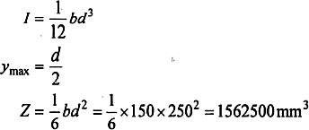
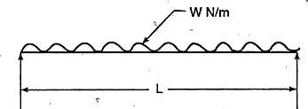
Moment carrying capacity M = σ Z = l0 x 1562500 N - mm
- If w is the intensity of load in N/m units, then maximum moment
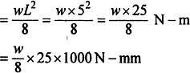
Equating it to moment carrying capacity, we get maximum intensity of load as
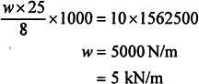
- If P is the concentrated load as shown in Fig., then maximum moment occurs under the load and its value
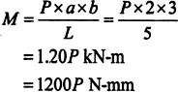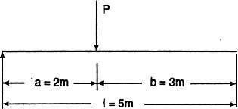
- A symmetric I-section has flanges of size 180 mm x 10 mm and its overall depth is 500 mm. Thickness of web is 8 mm. It is strengthened with a plate of size 240 mm x 12 mm on compression side. Find the moment of resistance of the section, if permissible stress is 150 N/mm². How much uniformly distributed load it can carry if it is used as a cantilever of span 3 m?
Solution
The section of beam is as shown in Fig. Let y be the distance of centroid from the bottom-most fibre.

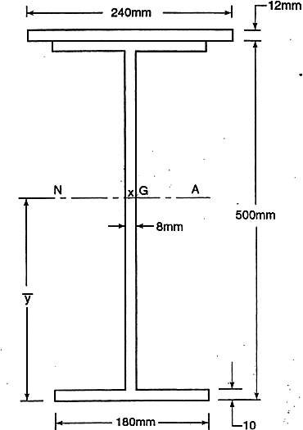
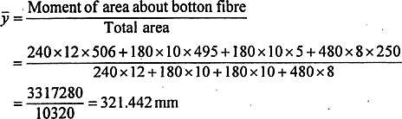
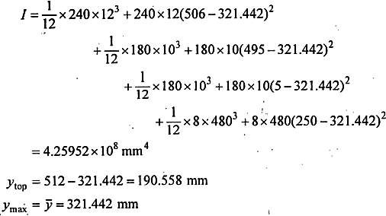

Moment of resistance (Moment carrying capacity)
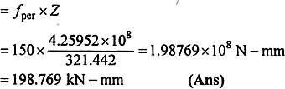

Let the load on cantilever be w/m length as shown in Fig.
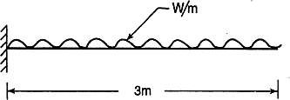
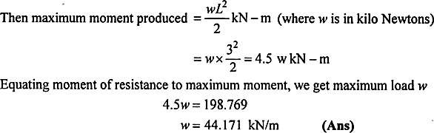

- A T-section is formed by cutting the bottom flange of an I-section. The flange is 100 mm x 20 mm and the web is 150 mm x 20 mm. Draw the bending stress distribution diagrams if bending moment at a section of the beam is 10 kN-m (hogging).
Solution
M = 10 kN-m = 10 x 10⁶ N mm (hogging)
Maximum bending stresses occur at extreme fibres, i.e. at the top bottom fibres which can be computed as
σ = My
I (i)
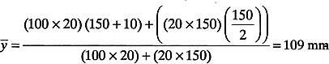

Moment of inertia is given by
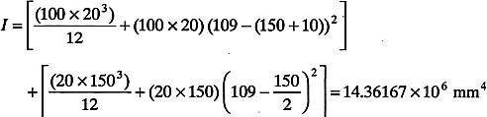

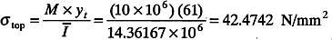
Substituting these values in Eq. (1), Stress in the top fibre =
Stress in the bottom fibre =
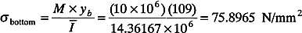

The given bending moment is hogging and hence negative and the tensile stresses occur at top fibre and compressive stresses in bottom fibres.
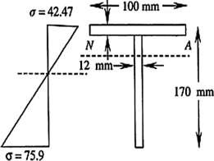

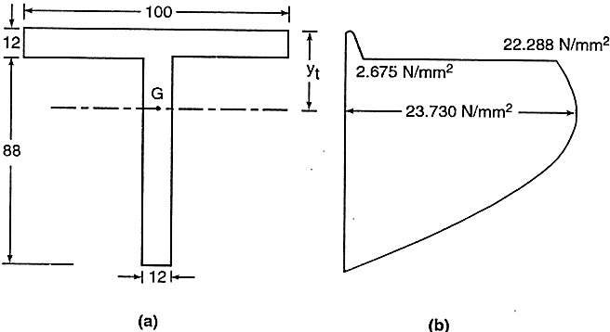
- Fig. shows the cross-section of a beam which is subjected to a shear force of 20 kN. Draw shear stress distribution across the depth marking values at salient points.

Solution

Let y, be the distance of C.G form top fibre. Then taking moment of area about top fibre and dividing it by total area, we get
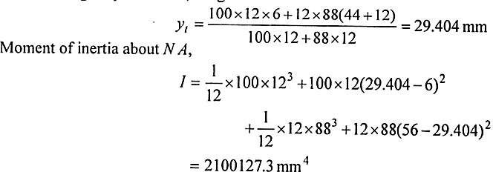

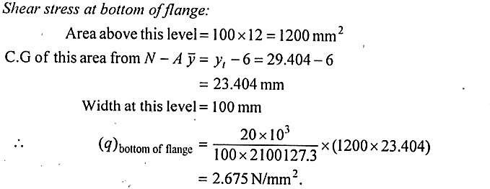

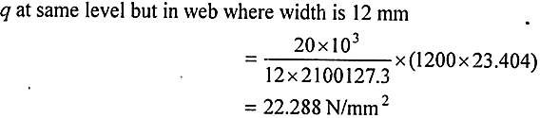
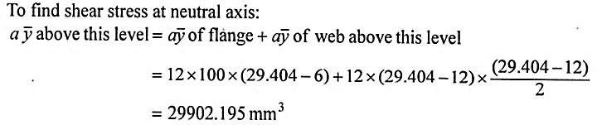
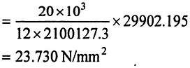

τ =
F
ay bI

Module V COLUMNS

INTRODUCTION
Buckling is characterized by a sudden sideways failure of a structural member subjected to high compressive stress, where the compressive stress at the point of failure is less than the ultimate compressive stress that the material is capable of withstanding. Mathematical analysis of buckling often makes use of an "artificial" axial load eccentricity that introduces a secondary bending moment that is not a part of the primary applied forces being studied. As an applied load is increased on a member, such as a column, it will ultimately become large enough to cause the member to become unstable and is said to have buckled. Further load will cause significant and somewhat unpredictable deformations, possibly leading to complete loss of the member's load- carrying capacity. If the deformations that follow buckling are not catastrophic the member will continue to carry the load that caused it to buckle. If the buckled member is part of a larger assemblage of components such as a building, any load applied to the structure beyond that which caused the member to buckle will be redistributed within the structure.

DEFINITIONS
Column: A vertical slender bar or member subjected to an axial compressive load is called a column.
Strut: A slender bar or member in any position other than vertical, subjected to an axial compressive load, is called a strut.
Slenderness ratio: It is the ratio of the length of the column to the minimum radius of gyration of the cross-sectional area of the column.
Buckling factor: The ratio between the equivalent lengths of the column to the minimum radius of gyration is called the buckling factor.
Buckling Load: When the axial load increases continuously on a column, at a certain value of the load, the column will just slightly be deflected or a little lateral displacement will take place in it. At this position, the internal forces which tend to straighten the column are just equal to the applied load. The minimum limiting load at which the column tends to have lateral displacement or tends to buckle, is called a buckling or crippling or critical load. Buckling takes place about the axis having minimum radius of gyration or least moment of inertia.
Safe load: The load to which a column is subjected and which is below the buckling load is

called the safe load. It is obtained by dividing the buckling load by a suitable factor of safety.

EULER'S FORMULA
In 1757, Swiss mathematician Leonhard Euler first analysed the long columns mathematically ignoring the effect of direct stress, and determined critical loads that would cause failure due to buckling only. His analysis is based on certain assumptions.
Assumptions Made in Euler's Column Theory
The following assumptions are made in the Euler's column theory:
- The column is initially perfectly straight and the load is applied axially.
- The cross-section of the column is uniform throughout its length.
- The column material is perfectly elastic, homogeneous, isotropic and obeys Hooke's law.
- The length of the column is very large as compared to its lateral dimensions.
- The direct stress is very small as compared to the bending stress.
- The column will fail by buckling alone.
- The self-weight of column is negligible.

Sign Conventions
The following sign conventions for the bending of the columns will be used:
- A moment which will bend the column with its convexity towards its initial central line is taken as positive
- A moment which will tend to bend the column with its concavity towards its initial centre line is taken as negative.
Expression for Crippling Load
In this section, we will derive expressions for buckling loads on columns with following end conditions:
- Both ends pinned (or hinged)
- One end fixed and other end free

Both ends fixed
- One end fixed and other end hinged

  - Both ends pinned (or hinged)
Consider a column AB of length l and uniform cross-sectional area, hinged at both of its ends A and B. Let P be the crippling load at which the column has just buckled. Due to the crippling load, the column will deflect into a curved form ACB as shown in fig. 8.5. Consider any section at a distance x from the end A. Let y = Deflection (lateral displacement) at the section.
The moment due to the crippling load at the section = - P . y

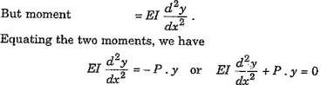

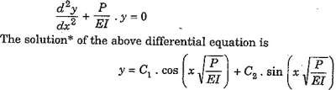

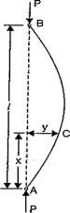
Fig. 8.5

(i)

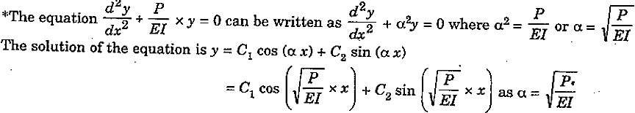

Where C₁ and C₂ are the constants of integration. The values of C₁ and C₂ are obtained as given below:
- At A, x = 0 and y = 0
Substituting these values in equation (i), we get
0 = C₁. cos 0° + C₂ sin 0
= C₁ x 1 + C₂ x 0
Therefore, C₁=0 (ii)
- At B, x=l and y = 0
Substituting these values in equation (i), we
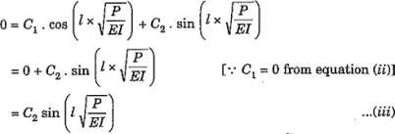
From equation (iii), it is clear that either C₂ = 0

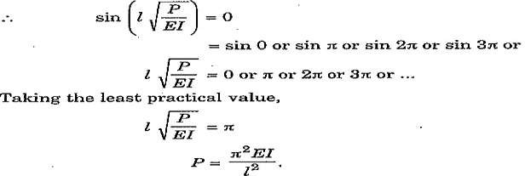
As C₁ = 0, then if C₂ is also equal to zero, then from equation (i) we will get y = 0. This means that the bending of the column will be zero or the column will not bend at all. This is not true.
  - One end fixed and other end free
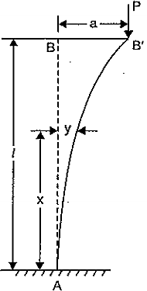
Consider a column AB, of length l and uniform cross-sectional area, fixed at the end A and free at the end B. The free end will sway sideways when load is applied at free end and curvature in the length l will be similar to that of upper half of the column whose both ends are hinged. Let P is the crippling load at which the column has just buckled. Due to the crippling load P, the column will deflect as shown in Fig. 8.6 in which AB is the original position of the column and AB', is the deflected position due to crippling load P. Consider any section at a distance x from the fixed end A.
Let y = Deflection (or lateral displacement) at the section Fig.8.6
a = Deflection at the free end B. Then moment at the section due to the crippling load = P (a - y)

But moment, M = EI

Equating the two moments, we get
d ² y

dx ²

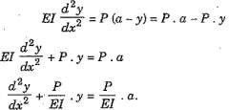
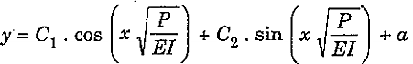
The solution* of the differential equation is

(i)

Where C₁ and C₂ are constant of integration; the values of C₁ and C₂ are obtained from boundary conditions. The boundary conditions are:
(i) For a fixed end, the deflection as well as slope is zero.

Hence at end A (which is fixed), the deflection y = 0 and also slope Hence at A, x = 0 and y = 0
Substituting these values in equation (i), we get
0 = C₁ cos 0 + C₂ sin 0 + a
= C₁ x l + C₂ x 0 + a
= C₁ + a (ii)
dy = 0
dx

At A, x = 0 and dy = 0
dx
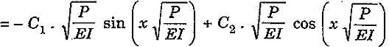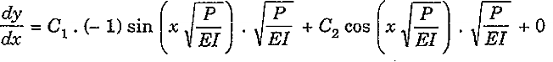Differentiating the equation (i) w.r.t. x, we get
But at x = 0 and dy = 0
dx
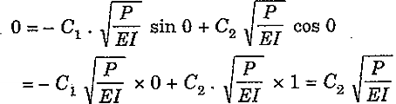
The above equation becomes as
P
EI
From the above equation it is clear that either C₂ = 0, or = 0

But for the crippling load P, the value of Therefore, C₂ = 0.
P
EI
cannot be equal to zero.

Substituting the values of C₁ = - a and C₂ = 0 in equation (i) we get
P
EI

⎛
y = −a ⋅ cos⎜ x
⎝
⎞
⎟ + a
⎠

(iii)

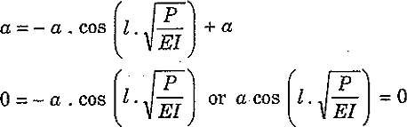
But at the free end of the column, x =l and y = a. Substituting these values in equation (iii) we get
But ‘a' cannot be equal to zero

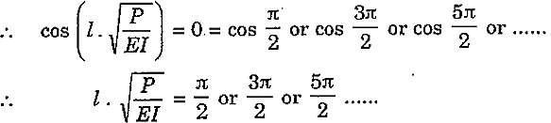
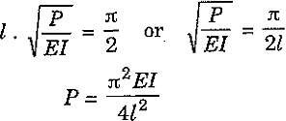
Taking the least practical value,

Module VI THOERY OF ELASTISITY

Syllabus
Introduction, Plane stress, stresses on inclined sections, principal stresses and maximum shear stresses, Mohr's circle for plane stress.

INTRODUCTION
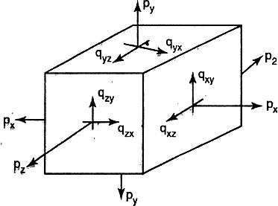
In actual Engineering problems combination of stresses will act. The member may be subjected to direct stresses in different directions. The shear stresses (direct or due to torsion) may also act. A beam is always under bending and shear. A shaft may be under torque, bending and direct forces. In this chapter we will see the effect of combined/compound stresses. In a three dimensional stress system, the various stresses acting are shown in Fig. 3.1.
Fig.3.1 Stress at a point
In many problems two dimensional idealizations is possible and the general stress system in such case is shown in Fig.3.2. In this book discussion is limited to two dimensional problems only.
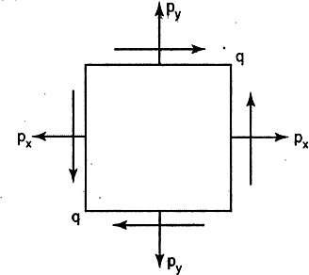
Fig. 3.2 2D Stress

STRESSES ON AN INCLINED PLANE
To find the stresses acting on an inclined plane in a stressed material we consider a general plane inclined at an angle θ to the known plane in an element and we find normal and tangential (shearing) stresses on this plane. The following three types of stressed conditions in an element are considered.
    - Uniaxial direct stresses
    - Biaxial direct stresses
    - General two dimensional stress system

ELEMENT SUBJECTED TO UNIAXIAL DIRECT STRESS
Consider the element subjected to direct uniaxial stress as shown in Fig. 3.3 (a & b). Now we are interested to find the normal and tangential stresses acting on plane DE which makes angle θ to the plane of stress P, θ is measured in anticlockwise direction. Fig. 3.3c shows the stresses acting on the element and Fig. 3.3d shows that forces acting. Consider the equilibrium of element CDE. Let the thickness of element be ‘t’ and depth be ‘a’
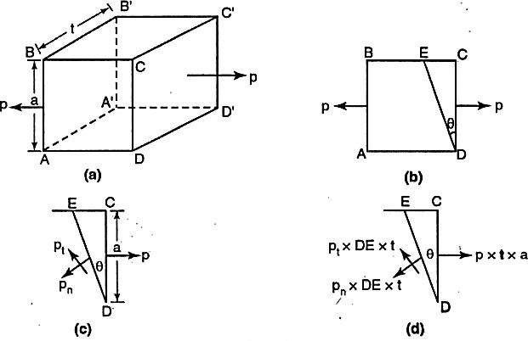
Fig. 3.3

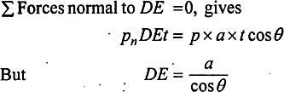

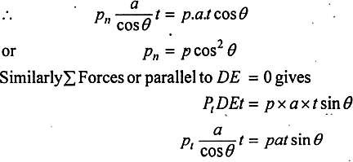
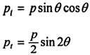

ELEMENTS SUBJECTED TO BIAXIAL DIRECT STRESSES
Consider the element shown in Fig. 3.4 subjected to direct tensile stresses, p₁ and p₂. Let the thickness of the element (perpendicular to plane of paper) be unity. Our interest is to study the stresses acting on plane DE, which makes anticlockwise angle θ with the plane p₁ stress.
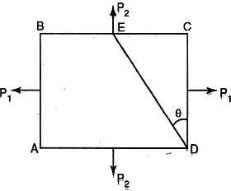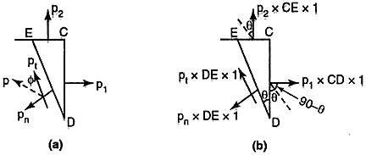
Fig.3.4 Fig.3.5
Now consider the element DCE shown in Fig. 3.5a and 3.5b. In Fig. 3.5a the stresses are shown in Fig. 3.5bb the forces acting are shown.

Σ Forces normal to plane DE =0, gives
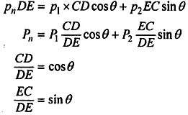
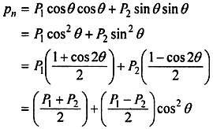

Σ Forces parallel to plane DE =0, gives
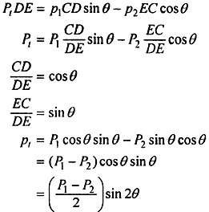
Resultant Stress on the plane
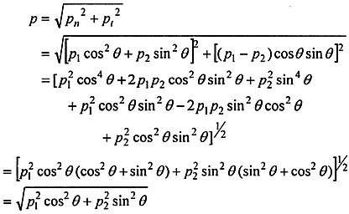
If the angle between the resultant stresses 'p' and the given plane is φ then
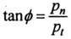
And hence, resultant makes angle φ + θ with the plane of p₁.

GENERAL STRESS SYSTEM
When a body is subjected to axial bending and shearing stresses, then the element in the body experiences a general two-dimensional stress system. The resultant of these stresses on any plane in the body can be resolved into a normal stress and shearing stress. Consider a small element subjected to two-dimensional stress system, as shown in Figure 3.6.

Normal Stress in an inclined plane
In this diagram, we have three stresses acting on an element, i.e. σ_{x}, σ_{y} and τ. To develop a relationship between the stresses acting on an inclined plane AC and the stresses σ_{x}, σ_{y} and τ. Consider the equilibrium of the element in Figure 3.6b. The forces acting parallel and perpendicular to the plane AC inclined at an angle θ with the horizontal are shown in Figure 3.6b.

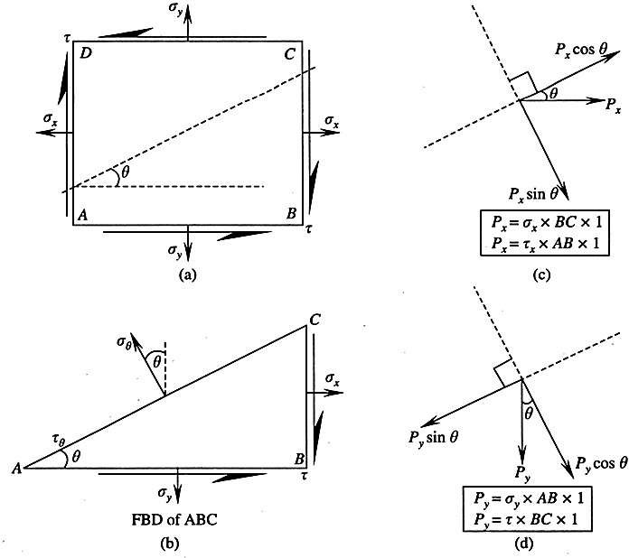
Fig.3.6: General stresses system
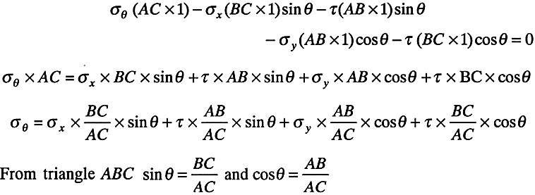
Considering the algebraic sum of forces perpendicular to the plane, acting away from AC as positive, we get,
Substituting these values, we get

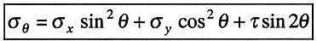
(3.1)

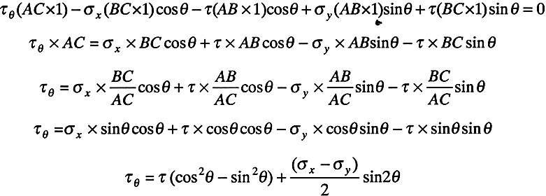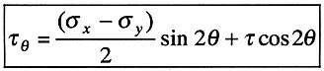The expression (3.1) gives the normal stress acting on any inclined plane. Similarly considering the algebraic sum of forces parallel to the plane acting downwards or along CA as positive, we get

Or (3.2)
The above expression (3.2) gives the shear stress acting on any inclined plane.
Sign conventions: The tensile normal stresses are considered as positive and shear stress developing clockwise rotation is treated as positive.

Maximum Normal Stress on an Inclined Plane
Equation (3.1) can be written as
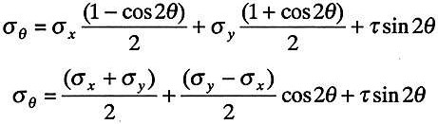 (3.1a)
Differentiating Eq. (3.1a), with respect to θ and equating to zero (maxima-minima), we get
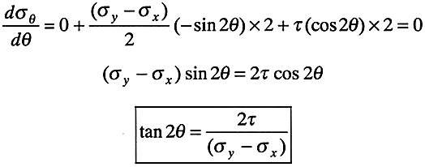 (3.3)
Equation (3.3) can be used to find the inclination of a plane for which the maximum normal stress is acting on it. Substituting τ_{θ} = 0 in Eq. (3.2), we get.
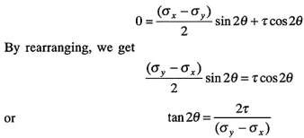

Hence, it is seen that on a plane where the normal stress is maximum, the shear stress is zero or absent.

Principal Planes and Principal Stress
In general stress system, the equation for normal and shear stress on an inclined plane is given by
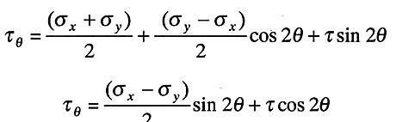
The normal stress is maximum on a plane inclined at an angle θ, given by
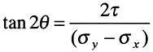
The plane on which the normal stress is maximum and shear stresses are absent is known as principal plane and the corresponding normal stress is principal stress. In general, at any point in a strained material, there are three principal planes mutually perpendicular to each other. Out of the three planes, the plane carrying maximum normal stress is called major principal plane and corresponding stress as major principal stress. The plane carrying minimum normal stress is called minor principal plane and corresponding stress as minor principal stress. In two- dimensional analysis, only two principal planes exist.
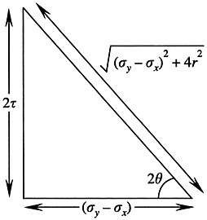
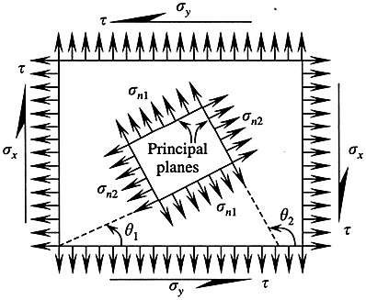
Consider Eq. (3.3), which represents inclination of principal plane. This can be represented with a right-angled triangle with an angle 2θ, as shown in Fig. 3.7.

Fig. 3.7 Right-angled triangle with an angle 2θ

Fig.3.8

From the triangle shown in Figure 3.7 and from trigonometry (Fig. 3.8), we know that
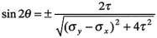

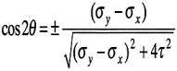
(3.4)
Substituting Eq. (3.4) in Eq. (3.1a), the principal stress is given by,
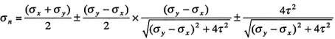
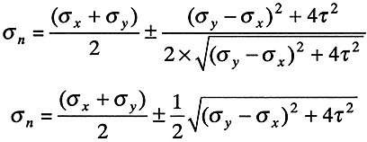

The principal stresses can be written as

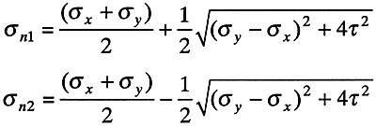
( 3.5 and 3.6)
Where σ_{n1} and σ_{n2} are known as principal stresses

Maximum Shear Stress
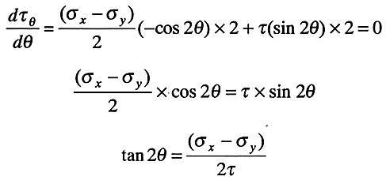
From Eq. (3.2), we have the shear stress on the inclined plane given by
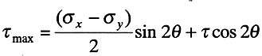
From maxima-minima, the maximum shear stress is obtained by differentiating Eq. (3.2) with respect to θ and equating it to zero.

This can be represented with a right-angled triangle with an angle 2θ, as shown in Figure 3.9.
From the triangle shown (from trigonometry), we know that
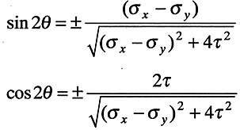 (3.7)

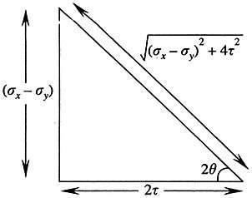

Substituting Eq. (3.7) in Eq. (3.2), we have
Fig. 3.9

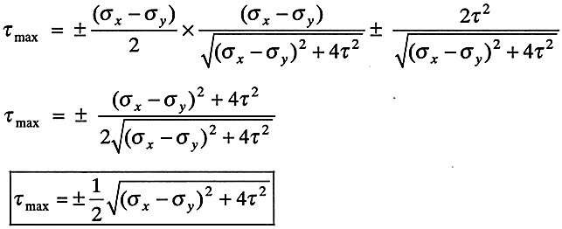
(3.8)
Comparing Eqs. (3.5), (3.6) and (3.8), we get

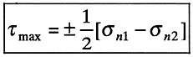
(3.9)
From Eq. (3.9), it is clear that maximum shear stress is equal to the half the algebraic sum of major and minor principal stresses. The planes of maximum shear stresses are inclined at 45° to the principal plane as the product of tan 2θ is -1. Hence, 2θ differs by 90° or 0 differs by 45º.

GRAPHICAL METHOD OF COMPOUND STRESS

3.6.1. Mohr's Circle
The circle used in the preceding section to derive some of the basic formulas relating to the transformation of plane stress was first introduced by the German engineer Otto Mohr (1835— 1918) and is known as Mohr's circle for plane stress. As you will see presently, this circle can be used to obtain an alternative method for the solution of the various problems. This method is based on simple geometric considerations and does not require the use of specialized formulas. While originally designed for graphical solutions, it lends itself well to the use of a calculator.

3.6.2 Construction of Mohr's Circle
Consider a square element of a material subjected to plane stress (Fig.3.10), and let σ_{x}, σ_{y} and τ_{xy}
be the components of the stress exerted on the element.
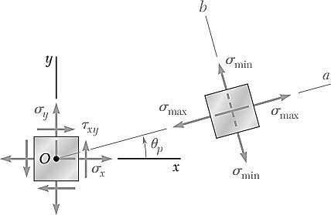
Fig. 3.10
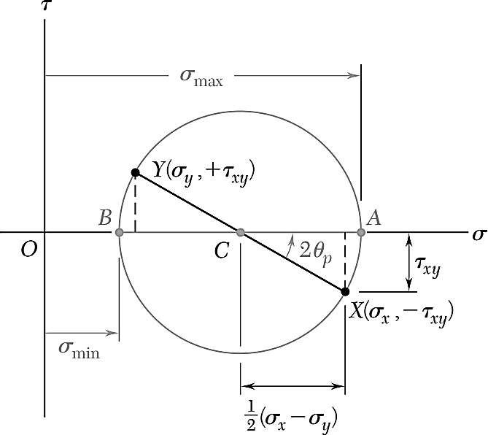
Fig. 3.11
We plot a point X of coordinates σ_{x} and -τ_{xy} and a point Y of coordinates σ_{x} and +τ_{xy} (Fig. 3.11). If τ_{xy} is positive, point X is located below the σ axis and point Y above, as shown in Fig. 3.11 &. If τ_{xy} is negative, X is located above the σ axis and Y below. Joining X and Y by a straight line,

we define the point C of intersection of line XY with the σ axis and draw the circle of center C and diameter XY. Noting that the abscissa of C and the radius of the circle are respectively equal to the quantities σ_{ave} and R defined by Eqs.
Thus the abscissas of points A and B where the circle intersects the σ axis represent respectively the principal stresses σ_{max} and σ_{min} at the point considered.
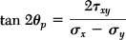
We also note that, since tan (XCA) = 2τ_{xy}/(σ_{x} – σ_{y}) the angle XCA is equal in magnitude to one of the angles 2θ_{p} that satisfy Eq.
Thus, the angle θ that defines in Fig. 3.10, the orientation of the principal plane corresponding to point A in Fig. 3.11 can be obtained by dividing in half the angle XCA measured on Mohr's circle.
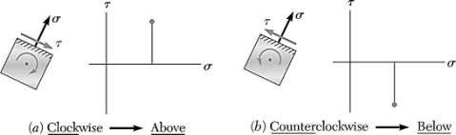
The construction of Mohrs circle for plane stress is greatly simplified if we consider separately each face of the element used to define the stress components. when the shearing stress exerted on a given face tends to rotate the element clockwise, the point on Mohrs circle corresponding to that face is located above the σ axis. When the shearing stress on a given face tends to rotate the element counterclockwise, the point corresponding to that face is located below the σ axis . As far as the normal stresses are concerned, the usual convention holds, i.e., a tensile stress is considered as positive and is plotted to the right, while a compressive stress is considered as negative and is plotted to the left.

WORKED EXAMPLES
- The direct stresses acting at a point in a strained material are as shown in Fig. Find the normal, tangential and the resultant stresses on a plane 30° to the plane of major principle stress. Find the obliquity of the resultant stress also.
Solution:
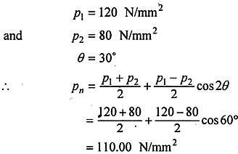

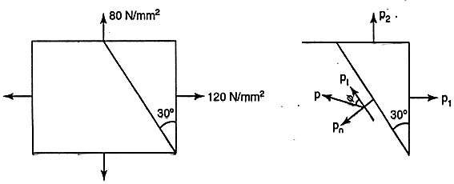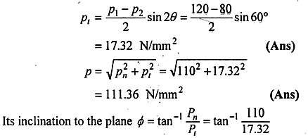
= 81.05° (as shown in Fig.) i.e., it makes 81.05 + 30 = 111.05° with the plane of 120 N/mm² stress.
- For the state of stress shown in Fig, determine the principal stresses and locate principal planes. Also obtain maximum tangential stress and locate corresponding planes.
Solution
Given: σ_{x} = 85 N/mm², σ_{y} = -60 N/mm², τ = 45 N/mm², σ_{n} = ?, θ = ?, τ_{max} = ?

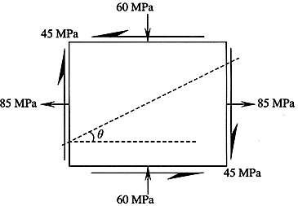

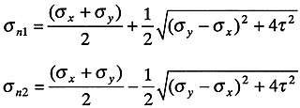
Principal stresses are given by
And its inclination is
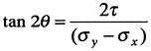

Maximum shear stress
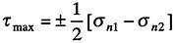
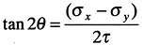
located at
Substituting the values
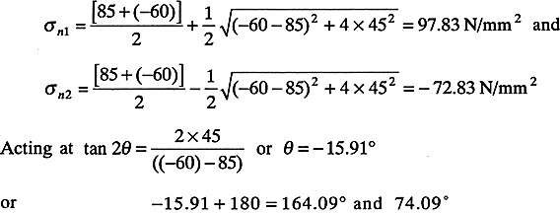

Magnitude of the maximum shear stress
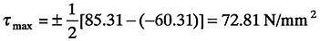
Location of the plane
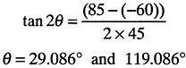

- For the state of plane stress shown in Fig., (a) construct Mohr's circle, (b) determine the principal stresses, (c) determine the maximum shearing stress and the corresponding normal stress.
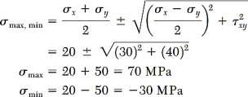
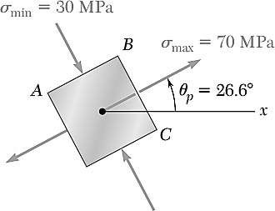
Solution:
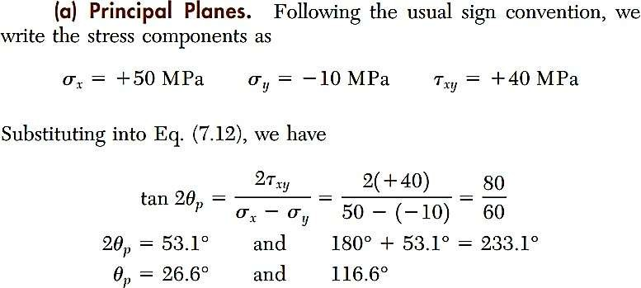
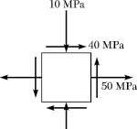

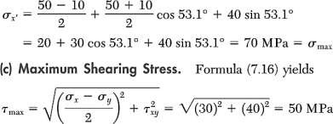
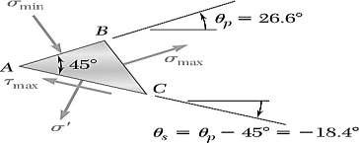

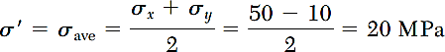
Construction of Mohr's Circle.
Note from Fig. that the normal stress exerted on the face oriented toward the x axis is tensile (positive) and that the shearing stress exerted on that face tends to rotate the element counterclockwise. Point X of Mohrs circle, therefore, will be plotted to the right of the vertical axis and below the horizontal axis . A similar inspection of the normal stress and shearing stress exerted on the upper face of the element shows that point Y should be plotted to the left of the vertical axis and above the horizontal axis.

Drawing the line XY, we obtain the center C of Mohrs circle; its abscissa is
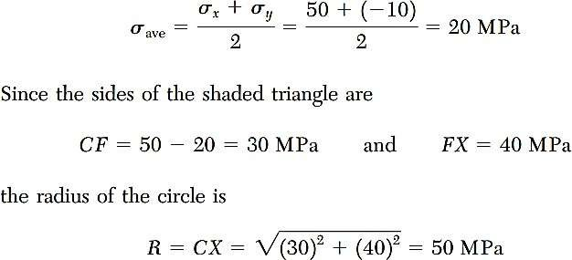
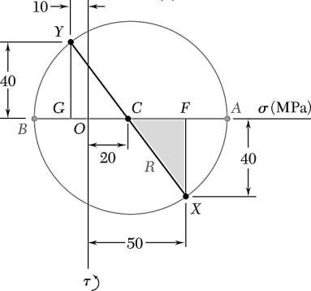
The following jingle is helpful in remembering this convention. "In the kitchen, the clock is above, and the counter is below.

- Principal Planes and Principal Stresses.
The principal stresses are
σ_{max} = OA = OC + CA = 20 + 50 = 70 MPa
σ_{min} = OB = OC - BC = 20 - 50 = -30 MPa
Recalling that the angle ACX represents 2θ., , we write
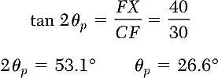

Since the rotation which brings CX into CA in Fig. is counterclockwise, the rotation that brings
Ox into the axis Oa corresponding to σ_{max} is also counterclockwise.

- Maximum Shearing Stress.
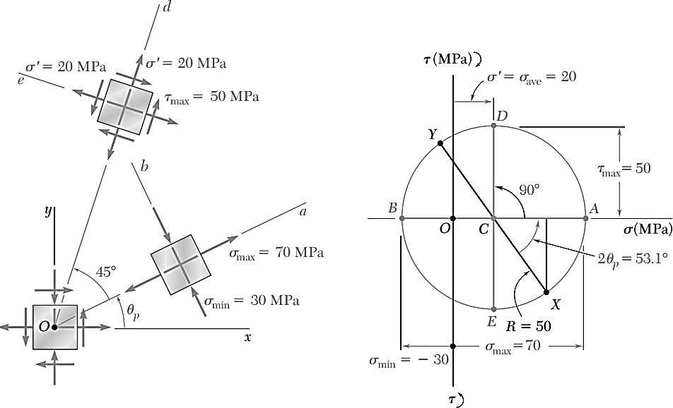
Since a further rotation of 90° counterclockwise brings CA into CD in Fig. a further rotation of 45° counterclockwise will bring the axis Oa into the axis Od corresponding to the maximum shearing stress in Fig. We note from Fig. that τ_{max} = R = 50 MPa and that the corresponding normal stress is σ’ = σ_{ave} = 20 MPa. Since point D is located above the σ axis in Fig. , the shearing stresses exerted on the faces perpendicular to Od must be directed so that they will tend to rotate the element clockwise.

- For the state of piano stress shown, determine (a) the principal planes and the principal stresses, (b) the stress components exerted on the element obtained by rotating the given element counterclockwise through 30°.
Solution:
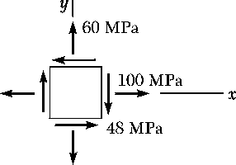
Construction of Mohr's Circle. We note that on a face perpendicular to there axis, the normal stress is tensile and the shearing stress tends to rotate the element clockwise; thus, we plot X at a point 100 units to the right of the vertical axis and 48 units above the horizontal axis. In a similar fashion, we examine
the stress components on the upper face and plot point
Y(60, - 48). Joining points X and Y by a straight line, we define the center C of Mohr's circle. The abscissa of C, which represents σ_{ave}, and the radius R of the circle can be measured directly or calculated as follows:

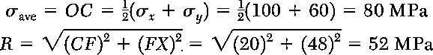

Principal Planes and Principal Stresses.
We rotate the diameter XY clockwise through 2θ„ until it coincides with the diameter AB. We have
The principal stresses are represented by the abscissas of points A and B:
Since the rotation that brings XY into AB is clockwise, the rotation that brings Ox into the axis Oa corresponding to σ_{max} is also clockwise; we obtain the orientation shown for the principal planes.
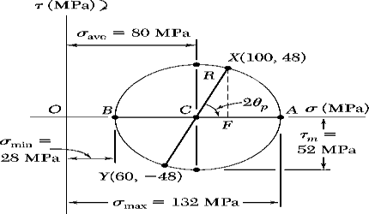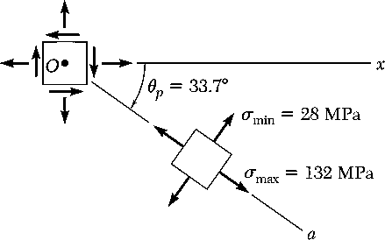

  - Stress Components on Element Rotated 30°
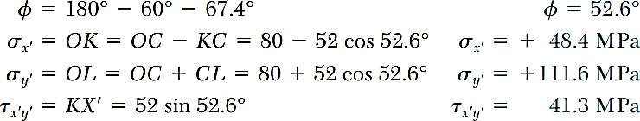
Points X' and Y' on Mohr's circle that correspond to the stress components on the rotated element are obtained by rotating XY counterclockwise through 2θ = 60°. We find

Since X' is located above the horizontal axis, the shearing stress on the face perpendicular to Ox'
tends to rotate the element clockwise.

